**APPLICATION FORMS**

**FOR FEDERAL**

**CAPITAL GRANTS**

**UNDER SECTION 5310**

**OF THE**

**FIXING AMERICA’S SURFACE TRANSPORTATION ACT**

**(FAST Act)**

**Enhanced Mobility of Seniors and Individuals With Disabilities Program**

**FY2020 and FY2021 Funding**

MARYLAND DEPARTMENT OF TRANSPORTATION

MARYLAND TRANSIT ADMINISTRATION

Office of Local Transit Support

9/2018

**MARYLAND DEPARTMENT OF TRANSPORTATION**

**MARYLAND TRANSIT ADMINISTRATION**

**SECTION 5310 PROGRAM APPLICATION**

**FY 2020 and FY 2021**

Table of Contents

INTRODUCTION AND PROGRAM INFORMATION 3

Introduction ……………………………………………………………………………………………… 4

Application Schedule 5

Planning and Coordination Requirements 7

Federal Requirements 7

Regional Coordination Plans in Maryland 7

Endorsement of Local Applications by Regional Coordination Bodies 8

Public and Transportation Operator Notice Requirements 8

Public Notice 8

Written Notification to Transportation Providers 9

Program Description 9

Program Purpose 9

Program Goals and Objectives 10

Eligible Applicants 10

Eligible Project Expenses 11

Local Match 13

Compliance with State and Federal Requirements 13

Project Selection Criteria and Method of Distributing Funds 14

Grant Awards for Vehicle Purchases 16

For More Information 17

PART I: APPLICATION INSTRUCTIONS AND FORMS

PART II: CERTIFICATIONS AND ASSURANCES

**INTRODUCTION AND**

**PROGRAM INFORMATION**

**MARYLAND DEPARTMENT OF TRANSPORTATION**

**MARYLAND TRANSIT ADMINISTRATION**

**SECTION 5310 PROGRAM APPLICATION**

**FY 2020 and FY 2021**

**Introduction**

As a result of Federal program changes following the enactment of the Fixing America’s Surface Transportation Act (FAST Act), the Section 5310 program now funds not only capital purchases such as vehicles, equipment, and Preventative Maintenance for private non-profit organizations, it also funds operating and mobility management projects.

**Program Purpose:**

To improve mobility for seniors and individuals with disabilities by removing barriers to transportation service and expanding transportation mobility options. This program supports transportation services planned, designed, and carried out to meet the special transportation needs of seniors and individuals with disabilities in all areas – large urbanized (over 200,000), small urbanized (50,000-200,000) and rural (under 50,000). Eligible projects include both traditional capital investments and non-traditional investment beyond the American with Disabilities Act (ADA) complementary paratransit services.

**APPLICATION SCHEDULE**

All applicants must adhere to the following schedule. There will be **NO EXCEPTIONS to these deadlines.**

**September 27, 2018**

* Program Announcement and application meetings with MTA staff.

**October 4-12, 2018**

* Application Meetings for any new organizations that wish to apply for 5310 grants:

|  |  |  |  |
| --- | --- | --- | --- |
| Thursday October 4, 2018 | 10:00 AM | Baltimore Metropolitan Council | 1500 Whetstone Way  Suite 300  Baltimore MD 21230 |
| Friday, October 5, 2018 | 10:00 AM | Southern Maryland Regional Transportation Coordination Committee | Tri-County Council for Southern Maryland  15045 Burnt Store Road  Hughesville MD 20637 |
| Thursday, October 11, 2018 | 10:30 AM | Tri-County Council for Western Maryland | 1 Technology Drive  Suite 1000  Frostburg MD 21532 |
| Friday, October 12, 2018 | 10:30 AM | Eastern Shore:  MUST and Tri-County Council Lower Eastern Shore | Eastern Shore Innovation Center  104 Tech Park Drive  Cambridge MD 21613 |

**October 29, 2018**

* Deadline for publishing public notice of application.
* Deadline for mailing letter of notification of application to existing private providers.

**November 30, 2018**

* Deadline for submission of comments by transportation providers and private citizens.
* Application Submission: Part I (1 hard copy and 1 electronic copy via Flash drive) to the Regional Planning offices: Baltimore Metropolitan Council or the Regional Coordination Body: Tri County Council of Lower Eastern Shore, Maryland Upper Shore Transit (MUST), Southern Maryland Regional Transportation Coordination Committee (RTCC) or Tri County Council of Western Maryland.

**December 14, 2018**

* Deadline for response from applicant to transportation providers and private citizens on their comments.

**December 31, 2018**

* Deadline for Regional Coordinating Body/Metropolitan Planning Organizations (MPO) to contact applicants to notify them that their projects were endorsed or not endorsed. (Endorsed applications must include their S. 5310 Certificate of Endorsement with their application to MTA).
* Deadline for Regional Bodies to send list of endorsed applications to MTA.

**January 11, 2019 – 3:00 PM**

* Deadline for submission of endorsed applications to the Maryland Department of Transportation (MDOT) Maryland Transit Administration.  **DO NOT USE THE UNITED STATES POSTAL SERVICE (USPS) REGULAR MAIL TO SEND YOUR APPLICATION. PLEASE HAND CARRY IT TO OUR OFFICES, SEND BY CERTIFIED MAIL OR USE A COURIER.**
  + Part I: submit 1 electronic copy, 1 paper original, 5 paper copies
  + Part II: submit 1 electronic copy, 1 paper original

**January 11-23, 2019**

* MTA will review Part II of the application for completeness.

**January 23, 2019**

* Endorsed applications will be sent to the 5310 Application Review Sub-committee of the State Coordinating Committee for Human Services Transportation (SCCHST) for scoring.

**February 20, 2019**

* Sub-committee will meet to review scores and rank projects.

**March 15, 2019**

* Final recommendations will be sent to MTA Capital Programing.

These deadlines **must** be met. If they are not met, the non-profit organization's application will not be accepted. **NO EXCEPTIONS**

**PLANNING AND COORDINATION REQUIREMENTS**

**Federal Requirements**

To be eligible for Section 5310 funding, FAST Act requires that projects funded through the Section 5310 Program be “included in a locally developed, coordinated public transit-human services transportation plan” that was “developed and approved through a process that included participation by seniors, individuals with disabilities, representatives of public, private, and nonprofit transportation and human services providers, and other members of the public.”

FTA guidance defines a coordinated public transit-human service transportation plan as one that identifies the transportation needs of individuals with disabilities, seniors, and people with low incomes, provides strategies for meeting those needs, and prioritizes transportation services for funding and implementation. Required elements of the plan are:

* An assessment of available services that identifies current transportation providers (public, private, and nonprofit);
* An assessment of transportation needs for individuals with disabilities and seniors. This assessment can be based on the experiences and perceptions of the planning partners or on more sophisticated data collection efforts, and gaps in service;
* Strategies, activities, and/or projects to address the identified gaps between current services and needs, as well as opportunities to achieve efficiencies in service delivery; and
* Priorities for implementation based on resources (from multiple program sources), time, and feasibility for implementing specific strategies and/or activities identified.

Detailed guidance from FTA on the coordinated planning requirements for the Section 5310 Program can be found on pages V-1 through V-10 in the most recent Section 5310 Program Circular (FTA C 9070.1G, issued July 7, 2014). This circular can be found on the FTA website at: <https://www.transit.dot.gov/sites/fta.dot.gov/files/docs/C9070_1G_FINAL_circular_4-20-15%281%29.pdf>.

**Regional Coordination Plans in Maryland**

In Maryland, preparing and updating locally developed, coordinated public transit-human services transportation plans are the responsibility of five (5) regional coordinating planning organizations. Each of the five (5) Statewide regions has developed a Coordinated Public Transit-Human Services Transportation Plan that 1) identified the transportation needs of individuals with disabilities, elderly individuals and individuals with low incomes, 2) provided strategies for meeting those local needs, and 3) identified potential projects that correspond to each strategy. These Maryland regional plans, which were initially completed in September 2007 and updated in September 2015, are available via the project website:

<http://www.kfhgroup.com/marylandcoordinationplans/>

The Washington, DC metropolitan area coordinated plan (which includes Montgomery and Prince George’s counties) is updated by MWCOG. The November 2014 updated plan can be found on the MWCOG website at: <https://www.mwcog.org/coordinated-human-service-transportation-plan/>.

The latest version of each region’s plan will serve as the basis for selection of projects to be funded through the MDOT MTA administered Section 5310 Program for State FY2020 and 2021. The Coordinated Transportation Plans have been updated as of September 2015 to meet the cycle required by FTA.

Applicants are encouraged to familiarize themselves with the current plan in their region to ensure their project is consistent with the plan. Additionally, applicants are expected to coordinate with other private, public, and non-profit and human services transportation providers. All awarded projects are required to be derived from their region’s Coordinated Public Transit-Human Services Transportation Plan.

**Endorsement of Local Applications by Regional Coordinating Bodies**

A required step in the local application process is to submit Part I of the application to the appropriate Regional Coordinating Body for endorsement. Regional Coordinating Bodies are responsible for reviewing local applications before they are submitted to the MDOT MTA and endorsing only those applications that are derived from/included in the current regional coordinated plan. **Indication of endorsement must be received from the appropriate Regional Coordinating Body prior to submitting the application to the MDOT MTA. The deadline for submission of Part I of applications to the Regional Coordinating Body is November 30, 2018. Please submit 1 hard copy and 1 electronic copy.**

Contacts for the Regional Coordinating Bodies can be found in the Appendix at the back of this application package.

**PUBLIC AND TRANSPORTATION OPERATOR NOTICE REQUIREMENTS**

Prior to submission of a Section 5310 application to the MDOT MTA, the applicant must provide formal notice to the general public as well as to operator transportation providers in the region, and address comments received as a result of these notifications.

**Public Notice**

Each applicant must publish a public notice in a local area wide newspaper briefly describing the transportation services your organization is proposing to provide with the vehicle or equipment for which you are applying in this application. Members of the public must be given an opportunity to submit comments on the proposed project to the applicant, and the applicant must respond to any comments received. All such comments and responses must be included as part of the final application. Specific requirements for this notice are found in Part II of the application package.

For this grant application cycle, the deadline for publishing the notice is **October 29, 2018**, the deadline for submission of comments from the public to the applicant is **November 30, 2018**, and the deadline for responding to any comments received is **December 14, 2018**.

**Written Notification to Transportation Providers**

To ensure that the Section 5310 program does not fund projects that will duplicate or compete with existing services, all transportation providers in the proposed service area of the Section 5310 grant application must be notified in writing, by postal mail, of the intended submittal. Transportation operators to be notified include public transit operators, private transit and paratransit operators such as charter bus and taxi operator, social service operators, particularly those funded previously under the Section 5310 or other Federal programs, and specialized transit operators funded by the Maryland Statewide Special Transportation Assistance Program (SSTAP).

All providers in the proposed service area must be informed of the proposed project so they can submit comments to the applicant, and the applicant must respond to any comments received. All such comments and responses must be included as part of the final application. Specific requirements for this notice are found in Part II of the application package, and lists of past recipients of FTA and Section 5310 grants are provided as an appendix.

For this grant application cycle, the deadline for mailing these notifications is **October 29, 2018** the deadline for submission of comments from transportation providers to the applicant is **November 30, 2018** and the deadline for responding to any comments received is **December 14, 2018**.

**PROGRAM DESCRIPTION**

**Program Purpose**

### Title 49 U.S.C. 5310 authorizes the formula assistance program for the Enhanced Mobility of Seniors and Individuals with Disabilities Program and provides formula funding to States and designated recipients (recipients) to improve mobility for seniors and individuals with disabilities. In Maryland, the Maryland Department of Transportation (MDOT) Maryland Transit Administration (MTA) has been designated by the Governor to receive these funds and administer the program.

### The Maryland Section 5310 program provides grant funds for capital and operating expenses to recipients for public transportation projects planned, designed, and carried out to meet the special needs of seniors and individuals with disabilities when public transportation is insufficient, inappropriate, or unavailable, as well as for alternatives to public transportation projects that assist seniors and individuals with disabilities with transportation.

### Program Goals and Objectives

### The goal of the Federal Section 5310 program is to improve mobility for seniors and individuals with disabilities throughout the country by removing barriers to transportation services and expanding the transportation mobility options available. Toward this goal, FTA provides financial assistance for transportation services planned, designed, and carried out to meet the special transportation needs of seniors and individuals with disabilities in all areas—large urbanized, small urbanized, and rural. The program requires coordination with other Federally assisted programs and services in order to make the most efficient use of Federal resources.

The program is designed to supplement other capital and operating assistance programs by funding transportation projects for seniors and individuals with disabilities in all areas -- urbanized, small urban, and rural. The program seeks to enhance coordination of State and Federally-assisted programs and services in order to encourage the most efficient use of resources and achieve the programs’ goal of improved mobility.

The objectives of the Section 5310 Program in Maryland are to:

* Maximize the use of funds available to the State of Maryland;
* Distribute funds in an equitable and effective manner;
* Promote and encourage applications from a broad spectrum of interested agencies;
* Establish criteria for evaluating applications for program funds;
* Provide technical assistance to organizations through workshops and administrative assistance; and
* Coordinate Maryland’s efforts to provide quality human services transportation services by working with appropriate Federal, State and local agencies, transit customers and transportation providers to develop a cooperative, coordinated, and human services transportation system.

**Eligible Applicants**

***Eligible Direct/Designated Recipients under the Federal Program***

Since the passage of FAST ACT, eligible direct recipients for Federal Section 5310 program funds include:

* Designated recipients in Urbanized Areas over 200,000 population:
* For the Washington Urbanized Area within the District of Columbia, Maryland and Virginia region, the designated recipient is Metropolitan Washington Council of Governments (MWCOG).
* For the Baltimore Urbanized area, the designated recipient is the MDOT MTA.
* States for all Rural and Small Urbanized Areas under 200,000 in population.
* Federally recognized Indian tribes for Section 5310 funds that a State or designated recipient has awarded to the tribe.

The designated recipient applies for funding from the FTA for itself and on behalf of sub-recipients, and in turn awards funding to sub-recipients.

***Eligible Local Applicants (Sub-recipients)***

Eligible applicants for Section 5310 funds in Maryland are private non-profit corporations that submit either:

* A copy of the Articles of Incorporation filed with the Maryland Department of Assessments and Taxation, or
* A copy of the determination from the U.S. Internal Revenue Service documenting their organization's private, non-profit status.

Although the Federal Section 5310 Program provides that a recipient may allocate funds to a State or local government authority under certain circumstances, the State of Maryland has determined that these public bodies will not be eligible to apply for Section 5310 funds for the following reasons:

* The limited funding available through the Section 5310 program is not adequate to meet the equipment needs of the non-profit organizations now eligible for funding. Approximately 50 percent of those applying each year actually receive funding.
* Non-profit organizations have extremely limited financial resources and few grant programs. Public bodies have access to expanded resources and broader access to grant programs.

### Eligible Project Expenses

As described under the coordinated planning requirements, all awarded Section 5310 projects are required to be derived from the most recent regional Coordinated Public Transit-Human Services Transportation Plans. In addition to being within a project derived from or included in the applicable regional plan, Section 5310 project funding eligibility is limited to the following types of project expenses.

***Eligible Capital Expenses***

In accordance with FTA guidance, at least 55 percent of Section 5310 funds must be utilized for public transportation capital projects that are planned, designed, and carried out to meet the specific needs of seniors and individuals with disabilities. Eligible capital expenses that meet this 55 percent requirement involve the following:

1. Rolling stock and related activities for Section 5310-funded vehicles
   1. Acquisition of expansion or replacement buses or vans, and related procurement, testing, inspection, and acceptance costs;
   2. Vehicle rehabilitation or overhaul;
   3. Preventative maintenance;
   4. Radios and communication equipment; and
   5. Vehicle wheelchair lifts, ramps, and securement devices.
2. Support equipment for Section 5310 Program
3. Computer hardware and software;
4. Transit-related intelligent transportation systems (ITS);
5. Dispatch systems.
6. Support for mobility management and coordination programs among public transportation providers and other human service agencies providing transportation. Mobility management activities may include:
7. The promotion, enhancement, and facilitation of access to transportation services, including the integration and coordination of services for individuals with disabilities, seniors, and low-income individuals;
8. Support for short-term management activities to plan and implement coordinated services;
9. The support of State and local coordination policy bodies and councils;
10. The operation of transportation brokerages to coordinate providers, funding agencies, and passengers;
11. The provision of coordination services, including employer-oriented transportation management organizations’ and human service organizations’ customer-oriented travel navigator systems and neighborhood travel coordination activities such as coordinating individualized travel training and trip planning activities for customers;
12. The development and operation of one-stop transportation traveler call centers to coordinate transportation information on all travel modes and to manage eligibility requirements and arrangements for customers among supporting programs; and
13. Operational planning for the acquisition of intelligent transportation technologies to help plan and operate coordinated systems inclusive of geographic information systems (GIS) mapping, global positioning system technology, coordinated vehicle scheduling, dispatching and monitoring technologies, as well as technologies to track costs and billing in a coordinated system, and single smart customer payment systems. (Acquisition of technology is also eligible as a standalone capital expense).

***Other Eligible Capital and Operating Expenses***

Up to 45 percent of a rural, small urbanized area, or large urbanized area’s annual apportionment may be utilized for the following:

1) Public transportation projects (capital only) planned, designed, and carried out to meet the special needs of seniors and individuals with disabilities when public transportation is insufficient, inappropriate, or unavailable;

2) Public transportation projects (capital and operating) that exceed the requirements of ADA;

3) Public transportation projects (capital and operating) that improve access to fixed-route service and decrease reliance by individuals with disabilities on ADA-complementary paratransit service; or

4) Alternatives to public transportation (capital and operating) that assist seniors and individuals with disabilities with transportation.

**Local Match**

The Section 5310 Federal share of eligible capital expenses may not exceed 80% of the net project costs, and the Federal share of eligible operating expenses may not exceed 50% of the net operating costs. A local match of 20% is required for capital projects, and 50% of the net operating costs for operating project.

The local match **must be provided in cash** for all projects.

All of the local share must come from sources other than Federal Department of Transportation (DOT) funds. Federal DOT program funds cannot be used as a source of local match for other FTA programs, even when used to contract for service. Some examples of non-DOT Federal funds are the Community Development Block Grant, and the Appalachian Regional Commission funds. Examples of other sources for local match monies that may be used for any or all of the local share include local appropriations, dedicated tax revenues, private donations, revenue from human service contracts, and net income generated from advertising and concessions.

**Compliance with State and Federal Requirements**

Section 5310 supplements other transportation funding programs and must be coordinated with those FTA programs and with transportation programs funded by other Federal and State sources. The coordinated planning requirements were described earlier in this application package.

Section 5310 funds may not be used to support services that compete with public transit or private-for-profit providers, or to provide transportation for school children. The program is subject to certain standard requirements of Federal programs including Title VI Civil Rights, Minority Business Enterprise, Equal Employment Opportunity, Americans with Disabilities Act/Nondiscrimination on the Basis of Handicap, Procurement, Drug-Free Workplace, Lobbying, Suspension and Debarment, and other applicable Federal and State requirements. Recipients of vehicle funding are also subject to minimum maintenance and insurance requirements throughout the useful life of the vehicle. As applicable, all Section 5310 grantees are subject to reporting and financial management requirements related to the grant, must provide MDOT MTA with a copy of their A-122 audit while the grant is active, and can expect MDOT MTA staff to conduct periodic site visits and review of program compliance. Many of the Federal and State requirements are listed within the certifications and assurances that must be signed and submitted as Part II of the Section 5310 application. These signed certifications and assurances will become part of the grant agreement if awarded.

**Project Selection Criteria and Method of Distributing Funds**

The MDOT MTA is the State agency designated by the chief executive officer of Maryland charged with developing project selection criteria. The MDOT MTA/OLTS conducts a competitive selection process that is separate, but coordinated with, the planning process.

Each local application must be submitted to the appropriate Regional Coordinating Bodies. The Regional Coordinating Bodies are facilitated by the following organizations:

* Baltimore Region (Annapolis, Anne Arundel, Baltimore, Carroll, Harford, and Howard counties and Baltimore City): Baltimore Metropolitan Council (BMC)
* Lower Eastern Shore (Somerset, Wicomico, and Worcester counties): Tri-County Council for the Lower Eastern Shore of Maryland
* Southern Maryland (Calvert, Charles, and St. Mary’s counties): Tri-County Council for Southern Maryland (TCCSMD)
* Upper Eastern Shore (Caroline, Cecil, Dorchester, Kent, Queen Anne’s, and Talbot counties): Maryland Upper Shore Transit (MUST)
* Western Maryland (Allegany, Frederick, Garrett, and Washington counties): Tri-County Council for Western Maryland (TCCWMD)
* Washington Region (Montgomery and Prince George’s counties): Metropolitan Washington Council of Governments (MWCOG)

**Note to applicants**: Applicants who provide all or most of their service within one region should send their applications to that Region. If some of your service originates or terminates in another region but your vehicles and services are “housed” in a “home” region, then send your project applications to the region where housed. Some applicants, however, have multiple facilities/locations across the state that operates under their organization’s administrative umbrella. If you are submitting a project request for more than one facility/location for your organization, then you must send a separate project application to each Regional Coordinating Body that applies.

The Regional Coordinating Bodies will review and endorse or not endorse each application/project within their region.

The Regional Coordinating Bodies send their recommendations to the MDOT MTA. The MDOT MTA then reviews the applications to ensure compliance and sends those that are responsive to the 5310 Review Sub-committee of the SCCHST to be scored and ranked for selection.

The committee will use the following criteria:

1. Extent and Urgency of Local Needs (10 pts.)

This criterion relates to project justification; i.e. the transportation needs to be met by an agency's proposed project, the urgency of these transportation needs, and the benefits that will accrue to elderly persons and persons with disabilities because of the transportation proposed in the application.

2. Coordination and Cooperation (20 pts.)

Proposed projects must be derived from the region’s Coordinated Transportation Plan. Other considerations include the degree to which the proposed project demonstrates coordination or cooperation among local service agencies and existing transit and paratransit operators. Coordination among agencies serving the elderly and agencies serving persons with disabilities is very important. Coordination may include the sharing of vehicles among agencies, or one agency transporting clients of another agency, or coordinating unused vehicle time with another agency, so that maximum vehicle utilization is achieved. This coordination will also take into consideration projects that do not include vehicles.

3. Vehicle Utilization (10 pts.)

Refers to the degree to which the service plan provides for the fullest possible utilization of the requested vehicle(s) as well as vehicles currently or proposed to be operated, i.e., ridership projections, miles, and hours of operations, etc. This also refers to proposed operational arrangements for project services.

4. Fiscal and Managerial Capability (10 pts.)

The degree to which the applicant appears to be capable of conducting the proposed project, with particular reference to the source and availability of both capital and operating funds and to the capacity of the agency for providing an efficient service. In particular, the provision of efficient transportation services, maintenance, driver training, and administrative oversight will be evaluated.

The maximum possible score is 50 points. Failure to complete any section will result in a score of zero for that section.

The selection process provides for a broad and equitable approach for selection of recipients for Section 5310 funds that meets the requirements of Title VI of the Civil Rights Act of 1964, which prohibits discrimination on the basis of race, color, or national origin in programs and activities receiving Federal financial assistance. The MDOT MTA/OLTS encourages participation of minority organizations and organizations that serve minority communities in the Section 5310 Program area.

Once the SCCHST has reached a decision on the award of grant funds, the MDOT MTA completes a single State-wide application that includes all the equipment and all necessary information on the successful applicant organizations.

The Statewide application is submitted for Federal approval. Local funding awards are contingent upon Federal funding award to the State.

**Grant Awards for Vehicle Purchases**

MDOT MTA conducts a centralized procurement of certain vehicles funded under the Section 5310 program on a State-wide basis on behalf of the sub-recipients.

The MDOT MTA will generally award the grants to purchase vehicles during the fall following the application period, subject to FTA funding approval.

Successful applicants for vehicle funding will be asked for their 20% local contribution upon delivery of the vehicles, which is typically one year after the grant application is submitted to the MDOT MTA.

The entire cycle, from the initial announcement of allocations is approximately as follows:

Program Announcement - Fall 2018

Application Deadline - Winter 2018

SCCHST Selection of Projects - Winter 2019

State Application Submission to FTA - Spring 2019

Federal Approval - Fall 2019

Procurement - Award - Spring 2019

Delivery - Winter 2020

The MDOT MTA will retain a lien on vehicles funded under the Section 5310 program until the vehicle meets useful life criteria (provided in part I of this application package) and the vehicle is retitled. The MDOT MTA/OLTS monitors vehicles funded through the Section 5310 program for which the MDOT MTA is a lien holder on the title, to ensure ongoing compliance with Federal and State requirements.

Procurement of sufficient vehicle insurance coverage is very important for the continued operation of your transportation program. We request that your agency review the insurance limit requirements outlined in this application on page 71. It is imperative that these limits be met by all grant recipients of Section 5310 funds.

**For More Information**

**If you need clarification on anything in this application, call or email the Program Manager.**

**Nancy Huggins**

**(410)-767-8356**

[**nhuggins@mta.maryland.gov**](mailto:nhuggins@mta.maryland.gov)

**THIS PAGE INTENTIONALLY LEFT BLANK**

**PART I**

**APPLICATION FORMS AND INSTRUCTIONS**

**MARYLAND DEPARTMENT OF TRANSPORTATION**

**MARYLAND TRANSIT ADMINISTRATION**

**SECTION 5310 PROGRAM APPLICATION**

**FY 2020 and FY 2021**

**GENERAL INSTRUCTION FOR YOUR FINAL SUBMISSION**

**Part I** of the application contains information that will be circulated to the Application Review Subcommittee of the SCCHST for their review, scoring and selection.

**SUBMIT THE ORIGINAL, FIVE PRINT COPIES AND ONE ELECTORNIC COPY OF PART I.**

**(Note: Please mark Original)**

**Part II** of the application contains the various assurances and requirements that must be met in order for your organization's application to be considered by the SCCHST.

**SUBMIT THE ORIGINAL AND ONE ELECTRONIC COPY OF PART II.**

**The General Information and Application Summary (next page)**

**must be the first page of your application**

THE DEADLINE FOR SUBMITTING APPLICATIONS THIS YEAR:

FRIDAY, JANUARY 11, 2019, 3:00 P.M.

NO EXCEPTIONS

Submit your application with the above-specified copies to:

**Ms. Nancy Huggins**

**Office of Local Transit Support, 8th Floor  
Maryland Transportation Administration**

**Maryland Transit Administration**

**6 St. Paul Street**

**Baltimore, MD 21202-1614**

**THIS MUST BE THE FIRST PAGE OF THE APPLICATION**

**GENERAL INFORMATION AND APPLICATION SUMMARY**

FY2020 and FY2021

|  |  |  |  |  |  |  |  |  |  |  |  |  |  |  |  |
| --- | --- | --- | --- | --- | --- | --- | --- | --- | --- | --- | --- | --- | --- | --- | --- |
| Legal Name of Applicant Organization:  DBA (Doing Business As) Name: IMPORTANT: DO NOT FORGET TO FILL IN THIS BOX  Federal Tax ID #: DUNS #: CAGE: | | | | | | | | | | | | | | | |
| Address | | | | | | | | | | | | | | | |
| **Contact Person** | **Name** | **Telephone Number** | | | | **Fax Number** | | | | **Email** | | | | | |
| Executive Director |  |  | | | |  | | | |  | | | | | |
| Project Director |  |  | | | |  | | | |  | | | | | |
| Primary Contact Person |  |  | | | |  | | | |  | | | | | |
| Counties Served |  | | | | | | | | | | | | | | |
|  | | | | | | | | | | | | | | | |
| **\*MTA Region(s) Which Proposed Projects Will Serve (check all that apply)** | | | | | | | | | | | | | | | |
| ___Baltimore Region (Annapolis, Anne Arundel, Baltimore, Carroll, Harford, and Howard counties and  Baltimore City)  ___Lower Eastern Shore (Somerset, Wicomico, and Worcester counties)  ___Southern Maryland (Calvert, Charles, and St. Mary’s counties)  ___Upper Eastern Shore (Caroline, Cecil, Dorchester, Kent, Queen Anne’s, and Talbot counties)  ___Western Maryland (Allegany, Frederick, Garrett, and Washington counties)  ___Washington Region (Montgomery and Prince George’s) | | | | | | | | | | | | | | | |
|  | | | | | | | | | | | | | | | |
| *Please refer to note on bottom of Page 14 to determine areas of service. | | | | | | | | | | | | | | | |
|  | | | | | | | | | | | | | | | |
| **Summary of Current Program and Services**  **(one trip equals one, one-way passenger trip)** | | | | | | | | | | | | | | | |
| # trips provided per day | | | | |  | | # lift vehicles in service | | | | | | |  | |
| # total vehicles in service | | | | |  | | # seats available | | | | | | |  | |
| # vehicles currently on order | | | | |  | | # wheelchair places available | | | | | | |  | |
|  | | | | | | | | | | | | | | | |
| **Estimated number of clients within the following groups who receive any of your agency’s services** | | | | **Number** | | | | | **Number of clients you transport with your agency’s transportation services* (these do not overlap)** | | | | | | |
| Black | | | |  | | | | |  | | Ambulatory | | | | Non-Ambulatory |
| Hispanic | | | |  | | | | | Elderly | |  | | | |  |
| American Indian | | | |  | | | | | Disabled | |  | | | |  |
| Asian or Pacific Islanders | | | |  | | | | | Total | |  | | | |  |
| Caucasian | | | |  | | | | | # of Eligible Low-Income Individuals _______ | | | | | | |
| Alaskan Native | | | |  | | | | | % of Eligible Low-Income Individuals ______ | | | | | | |
| Total Agency Clientele | | | |  | | | | |  | | | | | | |
| **Traditional: Vehicle, Equipment and Mobility Management Request in Priority Order** | | | | | | | | | | | | | | | |
| Description (Gas or Diesel if Vehicle)/ Other Equipment/PM/Mobility Management | | | | Replacement (Vehicle #) | | | | Expansion | | | | Rehab | Cost** | | |
|  | | | |  | | | |  | | | |  | $ | | |
|  | | | |  | | | |  | | | |  | $ | | |
|  | | | |  | | | |  | | | |  | $ | | |
|  | | | |  | | | |  | | | |  | $ | | |
|  | | | | | | | | | | | | | | | |
| **Application Budget (Estimated)** | | | | | | | | | | | | | | | |
| Total Budget | | | $ | | | | | | | | | | | | |
| Federal Funds (80%) | | | $ | | | | | | | | | | | | |
| Local Funds (20%) | | | $ | | | | | | | | | | | | |

* Age of your elderly clients depends on your agency’s guidelines
* Eligible Low-Income Individual is an individual whose family income is at or below 150 percent of the poverty line
* ** see page 61-62 for approx. cost

|  |  |  |  |  |
| --- | --- | --- | --- | --- |
| **Non-Traditional: Operating Request in Priority Order** | | | | |
| Program Name | | Federal | Local | Total Cost** |
|  | |  |  | $ |
|  | |  |  | $ |
|  | |  |  | $ |
|  | |  |  | $ |
|  | | | | |
| **Application Budget (Estimated)** | | | | |
| Total Budget | $ | | | |
| Federal Funds (50%) | $ | | | |
| Local Funds (50%) | $ | | | |

|  |  |  |  |  |
| --- | --- | --- | --- | --- |
| **Non-Traditional: Capital Request in Priority Order** | | | | |
| Program Name | | Federal | Local | Total Cost** |
|  | |  |  | $ |
|  | |  |  | $ |
|  | |  |  | $ |
|  | |  |  | $ |
|  | | | | |
| **Application Budget (Estimated)** | | | | |
| Total Budget | $ | | | |
| Federal Funds (80%) | $ | | | |
| Local Funds (20%) | $ | | | |

**Note: In order to determine priority, place the number of priority throughout all three boxes. Example: priority 1 is in the non-traditional (50/50), priority 2 is in non-traditional 80/20, Priority 3 is traditional (80/20).**

**AGENCY AND TRANSPORTATION PROGRAM INFORMATION**

Part I of application is to be submitted according to the format. You must submit each section, completed or labeled “N/A”, before your application will be considered complete. Sample charts should be duplicated as appropriate for use by the applicant.

Applications for financial assistance must contain or address the following in Part I of this application:

1. General Agency Information
2. Extent and Urgency of Local Needs
3. Coordination and Cooperation
4. Vehicle Utilization
5. Fiscal and Managerial Capability

**THIS PAGE INTENTIONALLY LEFT BLANK**

**PART I**

**GENERAL AGENCY INFORMATION**

**GENERAL AGENCY INFORMATION**

I. Please provide a brief agency description on a separate piece of paper. At a minimum, include in this description the following information:

a. Purpose of the agency

b. Specific goals of the agency

c. Length of time the agency has provided client services

d. Length of time the agency has provided transportation services

e. Brief overview of your transportation program

f. Specific ways in which your transportation program serves your agency’s clients

1. Geographic area served by your agency (region, county, or city)

II. Please complete the attached pages regarding your agency’s Civil Rights/Cell Phone Policies.

**A. CIVIL RIGHTS**

Do you employ 50 or more persons whose primary function deals with the transportation of clients?

**YES  NO**

How much State/Federal transportation funding did you receive in your last year of funding? ____________

Is the amount of State/Federal transportation funds more than $1 million in capital or operating assistance or in excess of $250,000 in planning assistance?

**YES  NO**

If you answered to either question above and are awarded a grant, you will be asked to develop a formal EEO program.

The State and any sub-recipients that receive funds from FTA for planning, capital, or operating assistance in excess of $250,000 to award in prime contracts, exclusive of funds for transit vehicle purchases, in a given Federal fiscal year must prepare a DBE program.

Is the amount of State/Federal transportation funds received in your last year of funding for planning, capital, or operating assistance more than $250,000?

**YES  NO**

If "Yes,” please provide a copy of your approved DBE program.

**If your organization does not have an FTA/MDOT MTA approved DBE plan, please contact your regional planner. A list of regional planners is included in the Appendix at the back of this document.**

Do you have an approved MDOT MTA/FTA Title VI Policy Statement/Plan?

**YES  NO**

Date of Approval

Please provide a copy of your most recent Title VI Policy Statement/Plan.

**If you do not have an approved plan, please contact your regional planner. A list of regional planners is included in the Appendix at the back of this document.**

**B. CIVIL RIGHTS CONTACTS - Applicant**

**EEO CONTACT - Applicant**

Name

Title

Department/Organization

Phone  E-Mail

Address

City, State ZIP

**ADA CONTACT - Applicant**

Name

Title

Department/Organization

Phone  E-Mail

Address

City, State ZIP

**Title VI CONTACT - Applicant**

Name

Title

Department/Organization

Phone  E-Mail

Address

City, State ZIP

**C. CELL PHONE USE**

Do you have a policy regarding the use of cell phones and other portable electronic devices for employees of your program?

**YES**  **NO**

Please attach a copy of your policy.

**PART I**

**EXTENT AND URGENCY**

**OF LOCAL NEEDS**

# EXTENT AND URGENCY OF AGENCY NEEDS

This section relates to project justification; i.e., the transportation needs to be met by your agency's proposed project, the urgency of these transportation needs, and the benefits that will accrue to the individuals with disabilities and elderly individuals because of the transportation proposed in the application.

In responding to the following questions please remember that it is very important that you provide a clear picture of the needs described above.

1. Please describe the proposed project. What equipment, facilities, or services would be funded if your request is approved? What is the time period of the proposed project? What counties, cities and towns would be served? Who would be eligible to use the services?

2. Describe the needs, urgency of these needs and benefits of this request. Please provide supporting information such as surveys, waiting lists, requests denied, planning documents, etc. You may need to use a separate piece of paper. (**Do not submit clients’ names with this application**.)

3. Is your agency requesting a **vehicle** in this application?

_______Yes _______No

If yes, is this vehicle an:

________ Replacement of 5310 vehicle

________ Replacement of non-5310 vehicle

________ Expansion

If Expansion, indicate reason for expansion:

________ Adding program component

________ Increasing number of clients

________ Insufficient number of vehicles for current agency needs

4. Is your agency requesting **equipment** other than a vehicle in this application?

_______Yes _______No

If yes:

Equipment Purpose (How it will be used in your transportation program)

______________ __________________________________________________________

__________________________________________________________

______________ __________________________________________________________

__________________________________________________________

5. Is your agency requesting **preventative maintenance** for Section 5310-funded vehicles in this application?

_______Yes _______No

If yes, please describe your maintenance program.

6. Is your agency requesting funding for **mobility management and coordination activities** in this application?

_______Yes _______No

If yes, please describe the activities to be supported by this funding.

7. Is your agency requesting funding for **public transportation alternatives that assist seniors and people with disabilities with transportation** in this application?

_______Yes _______No

If yes, please describe the services to be supported by this funding.

What is the need for these alternative services that current public transportation services are unable to meet?

8. Is your agency requesting **Operating** funding in this application?

_______Yes _______No

If yes, please describe the services to be supported by this funding.

9. Is this a scalable project?

_______Yes _______No

If yes, please describe how the project will be scaled back and still fit the need and urgency of the proposed project.

**AGENCY SERVICES CHART**

The chart on the following page should provide information on your agency, current transportation program description and justification for your application request. If it is necessary to provide additional or supporting information such as surveys, waiting lists, requests denied or planning documents, please include information as an attachment.

The Agency Description Chart requires two (2) categories of information: services provided, and clients served. The following is a definition and explanation of the information requested.

* **Age range of current clients** - What is the age range of the individuals with disabilities and elderly individuals currently served by your agency?
* **Age range eligible for serving** - Is your agency able to serve clients of a wider age range? If so, please indicate.
* **Services provided by agency** - Place an "X" next to all the services provided by your agency. Also indicate how much service is being provided by indicating on the chart the number of clients served by category. If a specific function of your agency is not listed, indicate as other and explain.
* **Current total clients** - How many clients are currently enrolled in your agency services?
* **Current riders** - How many clients are currently using your agency's transportation services per week, per service?
* **Total** - provide the total number of clients listed per column for each category of client. The total number of current individuals with disabilities and elderly individuals should be placed in column (1), etc.

|  |  |  |  |  |  |  |  |  |  |  |  |  |  |  |
| --- | --- | --- | --- | --- | --- | --- | --- | --- | --- | --- | --- | --- | --- | --- |
| Age Range of Current Clients |  | | |  |  | | | | | | | | | |
| Age Range Eligible for Serving |  | | |  |  | | | | | | | | | |
|  | Elderly/  Ambulatory | | Elderly/  Non-Ambulatory | | | | Disabled/  Ambulatory | | Disabled/  Non-Ambulatory | | Employment | | Total | |
|  | Current | Current | Current | | | Current | Current | Current Riders | Current | Current Riders | Current  Total  Clients | Current Riders | Current Total Clients | Current Riders |
| Total | Riders | Total | | | Riders | Total | Total |
| Clients |  | Clients | | |  | Clients | Clients |
| Service Provided by Agency: enter no. of Clients served per week |  |  |  | | |  |  |  |  |  |  |  |  |  |
| __________ Adult Day Care |  |  |  | | |  |  |  |  |  |  |  |  |  |
| __________ Nursing Home |  |  |  | | |  |  |  |  |  |  |  |  |  |
| __________ Vocational Training |  |  |  | | |  |  |  |  |  |  |  |  |  |
| __________ Activity Center |  |  |  | | |  |  |  |  |  |  |  |  |  |
| __________ Sheltered Workshop |  |  |  | | |  |  |  |  |  |  |  |  |  |
| __________ Senior Center/Services |  |  |  | | |  |  |  |  |  |  |  |  |  |
| __________ Residential Services |  |  |  | | |  |  |  |  |  |  |  |  |  |
| __________Family & Community Programs |  |  |  | | |  |  |  |  |  |  |  |  |  |
| __________ Medical Transportation |  |  |  | | |  |  |  |  |  |  |  |  |  |
| __________ Other |  |  |  | | |  |  |  |  |  |  |  |
| *Please indicate if new or expanded service. Elderly/Non-Ambulatory includes cognitive and physical disabilities. | | | | | | | | | | | | | | |

**THIS PAGE INTENTIONALLY LEFT BLANK**

**PART I**

**COORDINATION AND COOPERATION**

**PROJECT COORDINATION**

This section relates to the degree to which the proposed project demonstrates coordination or cooperation among local service agencies and existing transit and paratransit operators. Coordination and cooperation among agencies serving individuals with disabilities and elderly individuals is very important. To interface most effectively, service providers must be knowledgeable about each other's purpose, capabilities and areas served.

1. Please list below all other providers of transportation services to the individuals with disabilities and elderly individuals in your locality. (These operators must also be on the Operator Notification Certification in Part II.) Include public, private non-profit agencies. Next to the agency name, explain how your services are the same or differ from those of the named agency.

**Operator Type of Service provided Difference/Similarity**

2. Coordination of your organization's transportation with that operated by other providers can take many forms. Examples of some arrangements are: obtaining fuel and oil through a joint purchase agreement with another provider, obtaining maintenance for vehicles under an agreement with another provider, referring your clients to other agencies/operators, transporting other agencies' clients, or coordinating unused vehicle time with another agency, so that maximum vehicle utilization is achieved, having an ongoing and active advisory committee which includes agencies providing transportation, and providing training.

Explain how your transportation operation is or will be coordinated with existing services operated by public, private-non-profit, or private-for-profit transportation providers in your locality. Please use specific examples and include back-up documentation.

3. If other agencies do have use of your vehicles indicate:

**VIN# Agency % Operating Time**

4. Identify which Strategy(ies) within the Coordinated Public Transit-Human Services Transportation Plan this project responds to. (Regional Strategies can be found on the following pages. For Baltimore, Lower Eastern Shore, Southern Maryland, Upper Eastern Shore and Western Maryland, you would at least state the first strategy.) Explain how your agency implements this strategy/these strategies. Be sure to clearly explain how your project/services fit into the regional plan(s).

# Regional Strategies Identified in each Region’s Coordinated Public Transit-Human Services Transportation Plan

Note that the Baltimore, Southern Maryland, and Western Maryland regions identified multiple strategies as equally important priorities, while the Lower and Upper Shore regions ranked identified strategies in a priority order.

**Baltimore Area (Annapolis, Anne Arundel, Baltimore, Carroll, Harford, and Howard Counties and Baltimore City) – 2015 Plan Update**

* Continue to support capital needs of coordinated human service/public transportation providers.
* Improve coordination among public transportation and human service transportation providers.
* Expand availability of demand-response and specialized transportation services to provide additional trips for targeted populations.
* Provide flexible transportation options and more specialized and one-to-one services through expanded use of volunteers.
* Provide “centralized point of access” that offer information on available aging and disability resources and/or offer travel training to targeted populations.
* Expand availability of accessible transportation services.
* Expand access to taxi and other private transportation providers.
* Initiate Performance Management Approach.

**Lower Eastern Shore (Somerset, Wicomico, and Worcester Counties) – 2015 Plan Update**

* Maintain existing services through appropriate operating and capital funding.
* Ensure customers are aware of existing transportation options and can use these services effectively.
* Expand public transportation options in the region.
* Expand specialized transportation services for people who unable to use or access public transit services.
* Consider a broader variety of transportation services that target specific needs identified through the coordinated transportation planning process.
* Secure additional funding and resources to support community transportation services.
* Provide more flexible transportation services that respond to seasonal nature of the region.
* Improve coordination and connectivity in the region.

**Southern Maryland (Calvert, Charles, and St. Mary’s Counties)** **– 2015 Plan Update**

* Maintain existing services through appropriate operating and capital funding.
* Ensure customers are aware of existing transportation options and can use these services effectively.
* Expand public transportation options in the region.
* Expand specialized transportation services for people who are unable to use or access public transit services.
* Consider a broader variety of transportation services that target specific needs identified through the coordinated transportation planning process.
* Secure additional funding and resources to support community transportation services.
* Improve coordination and connectivity in the region.

**Upper Eastern Shore (Caroline, Cecil, Dorchester, Kent, Queen Anne’s, and Talbot Counties) – 2015 Plan Update**

* Maintain existing services through appropriate operating and capital funding.
* Ensure customers are aware of existing transportation options and can use these services effectively.
* Expand public transportation options in the region.
* Expand specialized transportation services for people who are unable to use or access public transit services.
* Consider a broader variety of transportation services that target specific needs identified through the coordinated transportation planning process.
* Secure additional funding and resources to support community transportation services.
* Improve coordination and connectivity in the region.

**Washington, DC (Montgomery and Prince George’s Counties) – November 19, 2014 Updated Plan**

**Strategies for Improved Coordination and Services**

***I. Coordinate Transportation Services and Programs***

* Improved service and agency communication across jurisdictions at the local and

State levels on transportation (public, non-profit, private and Medicaid).

* Coordination should improve services for customers and reduce cost to agencies.
* Improve Local and State Interagency coordination with planning efforts and

mobility managers.

* Improve Nonprofit agency coordination.
* Involve Private transportation Providers.
* Provide customer services that plan for the whole trip, and not simply the ride, i.e., individuals often need information about various transportation options, and assistance in researching those options and planning and preparing for the trip.

***II. Provide Customer-Focused Services, Improve Marketing and Training***

* Train transportation managers, agency staff and others who have direct contact with customers to improve communication, interactions and understanding of user’s needs and concerns.
* Train customers on the use of available options, including but not limited to fixed-route services.
* Provide tailored transportation services for low-income individuals with physical and developmental disabilities and older adults.
* Market and advertise existing services; target and customize information to people who need them most, such as people who utilize public housing, senior centers, adult day care and dialysis facilities.
* Improve information on existing services and provide in appropriate formats (including electronic media) to customers, caregivers, social service and nonprofit agencies -- both public and specialized – that are available to people with disabilities and that can most effectively meet their transportation needs.

***III. Improve the Accessibility and Reliability Existing Services***

* Provide alternatives to traditional fixed-route transit and paratransit with an emphasis on shared rides and privately-provided services.
* Improved connections to existing services, including first mile/last mile connections, such as improved infrastructure, deviated route services, shuttles, or taxis to transit stations. These connections are critical in areas where services have been cut.
* Improve pathways and physical infrastructure at bus and rail stations.
* Provide better methods for reporting needed bus stop and sidewalk improvements.

***IV. Develop and Implement Additional Transportation Options***

* Improve the frequency, availability and accessibility of specialized services (both capital and operating improvements).
* Provide services or programs that cross jurisdictional boundaries travel, as well as services that can effectively accommodate individual trip requirements.
* Additional funding should be identified and secured to support and sustain these programs.

***Priority Projects:***

1. Mobility Manager Positions at the Local Government Level
2. Challenge Grant for Coordinated Planning Efforts
3. Personal Mobility Counseling Services
4. Travel Training
5. Door-through-Door or Escorted Transportation Service
6. Expanded and On-Going Sensitivity and Customer Service Training for Drivers
7. Shuttle or Taxi service to Bus Stops and Rail Stations
8. Bus Stop and Sidewalk Improvements
9. Deviated Bus or Feeder Service for Targeted Area or Population Groups
10. Pilot Programs that Expand the Use of Taxis for Medical Trips
11. Volunteer Driver Programs
12. Tailored Transportation Service for Clients of Human Service Agencies

**Western Maryland (Allegany, Frederick, Garrett, and Washington Counties) – 2015 Plan Update**

* Maintain existing services through appropriate operating and capital funding.
* Ensure customers are aware of existing transportation options and can use these services effectively.
* Expand public transportation options in the region.
* Expand specialized transportation services for people who are unable to use or access public transit services.
* Consider a broader variety of transportation services that target specific needs identified through the coordinated transportation planning process.
* Secure additional funding and resources to support community transportation services. Expand access to employment opportunities in the region.
* Improve coordination and connectivity between transportation providers in the region.

**THIS PAGE INTENTIONALLY LEFT BLANK**

**THIS PAGE MUST BE INCLUDED IN EACH APPLICATION**

**SERVICE CONTRACTS**

¨ List any current or proposed contracts or other agreements your organization has for providing transportation to other agencies. Attach copies to Part I.

**Check here if this is not applicable _______**

¨ List names and addresses of any public or private transportation provider from which your organization purchases, or plans to purchase, transportation service.

**Check here if this is not applicable _______**

**THIS PAGE INTENTIONALLY LEFT BLANK**

**PART I**

**VEHICLE UTILIZATION**

**AND**

**REQUESTED VEHICLES**

**VEHICLE UTILIZATION**

**1. Vehicle and Equipment Request in Priority Order:**

|  |  |  |  |  |
| --- | --- | --- | --- | --- |
| **Description** | **Expansion** | **Replacement** | **Rehabilitation** | **Cost** |
| **1.** |  |  |  | **$** |
| **2.** |  |  |  | **$** |
| **3.** |  |  |  | **$** |
| **4.** |  |  |  | **$** |

**2. Vehicle Replacement**

If replacement vehicles are being requested, complete the following for each vehicle to determine

eligibility: (Criteria for replacement follows chart).

Since there is a lag period between the time of your application and the actual delivery date of an

approved vehicle, allowance must be made for the mileage which will be added to the vehicle during this lag time.

The following formula should be used to account for this additional mileage and thereby

determine if your vehicle will meet the minimal service life criteria.

|  |  |  |
| --- | --- | --- |
| **Vehicle Description** | **Vehicle to be replaced** | **Vehicle to be replaced** |
| Vehicle Identification Number |  |  |
| Date Vehicle was placed in service |  |  |
| Current Date |  |  |
| Total Months of Ownership |  |  |
| Current Vehicle Mileage  (Date _____________) |  |  |
| Average Miles per Month (Current Mileage divided by Total Months of Ownership) |  |  |
| Projected Mileage (Average Mileage per Month X 36 Projected Months) |  |  |
| **Total Vehicle Mileage** (Current & Projected Mileage) |  |  |
| Projected Age of Vehicle in Months (Total Months of Ownership + 36 Months) |  |  |
| Total Age of Vehicle (in years) (Projected Age of Vehicle in Months divided by 12) |  |  |
|  |  |  |

If you are awarded a Section 5310 replacement vehicle, how will you dispose of the vehicle to be replaced?

______Sell Vehicle _______Use Vehicle as Backup _____Junk Vehicle ______Other

* If requesting more than two vehicles to be replaced, please duplicate this form and include with application

**Minimum Vehicle Service-Life Policy**

**Minimum Service-Life Standards**

To ensure that vehicles are adequately maintained and remain in service for their normal service life, the Maryland Department of Transportation (MDOT) Maryland Transit Administration (MTA) has established minimum service-life standards for vehicles funded with State or Federal funds. These standards apply to all vehicles purchased with Sections 5307, 5309, 5310, 5311, 5316, 5317, American Disabilities Act (ADA), or Statewide Special Transportation Assistance Program (SSTAP) funds, and to all vehicles that will be replaced with vehicles funded from these programs, regardless of the initial funding source.

Service-life begins on the date the vehicle was placed in service and continues until it is removed from service.

|  |  |  |
| --- | --- | --- |
| **Classification** | **Yrs.** | **Miles** |
| Small Specialized Vehicles (Accessible Minivans and Accessible Taxicabs) & Sedans | 4 years | 100,000 |
| Light Duty Small Bus (Cutaway) | 5 years | 150,000 |
| Medium Duty Bus | 7 years | 200,000 |
| Heavy Duty Bus | 10 years | 350,000 |
| Heavy Duty Bus | 12 years | 500,000 |

**Vehicle Classifications**

* Small Specialized Vehicles (Accessible Minivans and Accessible Taxicabs) & Sedans: at least four (4) years of service or an accumulation of at least 100,000 miles.
* Light Duty Small Bus, body on chassis-type (cutaway): at least five (5) years of service or an accumulation of at least 150,000 miles.
* Medium duty transit buses: at least seven (7) years of service or an accumulation of at least 200,000 miles.
* Heavy duty transit buses: at least ten (10) years of service or an accumulation of at least 350,000 miles.
* Heavy duty transit buses: at least twelve (12) years of service or an accumulation of at least 500,000 miles.

Although a minimum standard for service-life is adopted, additional information about the condition of the vehicle is necessary for all replacement requests. Vehicles will not be replaced based solely on age and accumulated mileage, therefore details such as repair records or estimated repair costs must be provided with the request.

Below is minimum information that is requested to submit for a replacement vehicle. Use forms provided in the applications.

* Fleet Vehicle Number,
* Present Mileage,
* Vehicle Identification Number and delivery date (if the vehicle to be replaced was purchased under a previous Sections 5307, 5309, 5310, 5311, 5316, 5317, ADA, or SSTAP grant),
* A description of the condition of the vehicle to be replaced, including the reasons for replacing the vehicle at this time, and
* An indication of how the vehicle will be disposed of (sell, salvage, or used as backup or other). **NOTE:** any insurance proceeds received for this vehicle will be deducted from MDOT MTA’s State and Federal portion of the eligible cost of a replacement vehicle.

**Replacement Prior to Meeting Minimum Service-Life Criteria**

If a replacement vehicle is being requested for a vehicle which has not or will not meet the established Service-Life criteria, the applicant must describe the circumstances necessitating the replacement of the vehicle. The applicant would need to complete the information above, in addition to providing the following information:

* A list of any repairs that will be required to keep the vehicle in service, and an estimated cost of each repair,
* A description and cost of repairs made to the vehicle to date (attach the repair and preventative maintenance records, if available).

FTA classifies this as early asset replacement.

**Vehicle Rehabilitation**

If you are applying for funding for vehicle rehabilitation, identify each vehicle to be rehabilitated,

give a description of work to be done for each and provide an estimate for the cost of rehabilitation.

Note: Rehabilitation of vehicles will only be approved for those vehicles purchased with FTA funds or if the Maryland Department of Transportation is added on the vehicle title. Rehabilitated vehicles will not be eligible for replacement until at least three years after rehabilitation takes place.

A vehicle may be rehabilitated if:

.. it is at least four (4) years old or has 100,000 miles (this may be projected in accordance with the vehicle replacement formula chart).

.. the cost of the rehabilitation is less than 50% of the purchase price of a “like” vehicle.

.. the rehabilitation work restores the vehicle to a “nearly new” vehicle status

.. the vehicle can meet, after rehabilitation, the current Section 5310 safety standards and specifications

.. the rehabilitation work will add 36 months or approximately 65,000 miles to the life of the vehicle

If such rehabilitation work is approved for funding under this Section 5310 application, the MDOT MTA will have final approval on specifications and solicitation.

**Vehicle Inventory**

Please complete this form for your agency’s entire vehicle inventory. List all vehicles in the following order:

.. vehicles that are to be replaced or rehabilitated; [list highest priority first]

.. currently used vehicles that will not be affected by this application;

.. vehicles that are currently on order through a previous year’s application or another funding source and are yet to be received.

If you are replacing a vehicle in which the status is inactive or back up, please explain why. The Committees’ current policy is not to replace inactive or back up vehicles unless adequate justification is made. Use a separate page if needed to explain in detail. If a vehicle is used daily during peak service, it is not considered a backup vehicle.

**THIS PAGE INTENTIONALLY LEFT BLANK**

|  |  |  |  |  |  |  |  |  |  |  |  |  |  |  |  |  |  |  |  |  |  |  |  |  |  |  |  |  |  |  |  |  |  |  |  |  |
| --- | --- | --- | --- | --- | --- | --- | --- | --- | --- | --- | --- | --- | --- | --- | --- | --- | --- | --- | --- | --- | --- | --- | --- | --- | --- | --- | --- | --- | --- | --- | --- | --- | --- | --- | --- | --- |
|  | **Section 5310 Program Application for FY 2020 and FY 2021** | | | | | | | | | | | | | | | | | | | | | | | | | | | | | | | | | | | |
|  | **Jurisdiction** | | | | | | | | | | | | | | | | | | | | | | | | | | | | | | | | | | | |
|  | **Organization** | | | | | | | | | | | | | | | | | | | | | | | | | | | | | | | | | | | |
|  | | |  | | |  | |  | | |  | |  | |  | |  | | |  | | | |  | |  | |  | |  |  | |  | |  | |
|  | **Form 6: VEHICLE INVENTORY** | | | | | | | | | | | | | | | | | | | | | | | | | | | | | | | | | | | |
|  | | |  | | |  | |  | | |  | |  | |  | |  | | |  | | | |  | |  | |  | |  |  | |  | |  | |
|  | *Indicate all vehicles currently owned by the applicant organization, as well as vehicles requested in* ***FY20/21*** *and funded in previous years that are currently on order, for your* ***transportation*** *program. Insert additional pages as needed.* | | | | | | | | | | | | | | | | | | | | | | | | | | | | | | | | | | | |
|  |
|  | |  | |  | | |  | |  | | |  | |  | |  | | | |  |  | | | |  | |  | |  | | |  | |  | |  |
| Agency Fleet Number | | Vehicle Identification Number (VIN) | | Model Year | | | Make | | Vehicle Type | | | Title Number | | Equipped with Lift or Ramp? | | Seating Capacity | | | | | | Communi-cations Equipment | | | Capital Funding Source | | Current Mileage | | Current Status | | | Average Annual Mileage | | Fiscal Year Budgeted for Replace-ment | |  |
| Ambu-latory | | Wheel-chair | | | |  |
| **REVENUE VEHICLES:** All vehicles used for client transportation & all 5310 vehicles | | | | | | | | | | | | | | | |  | |  | | | |  | | |  | |  | |  | | |  | |  | |  |
|  | |  | |  |  | | | |  | | |  | |  | |  | |  | | | |  | | |  | |  | |  | | |  | |  | |  |
|  | |  | |  |  | | | |  | | |  | |  | |  | |  | | | |  | | |  | |  | |  | | |  | |  | |  |
|  | |  | |  |  | | | |  | | |  | |  | |  | |  | | | |  | | |  | |  | |  | | |  | |  | |  |
|  | |  | |  |  | | | |  | | |  | |  | |  | |  | | | |  | | |  | |  | |  | | |  | |  | |  |
|  | |  | |  |  | | | |  | | |  | |  | |  | |  | | | |  | | |  | |  | |  | | |  | |  | |  |
|  | |  | |  |  | | | |  | | |  | |  | |  | |  | | | |  | | |  | |  | |  | | |  | |  | |  |
|  | |  | |  |  | | | |  | | |  | |  | |  | |  | | | |  | | |  | |  | |  | | |  | |  | |  |
|  | |  | |  |  | | | |  | | |  | |  | |  | |  | | | |  | | |  | |  | |  | | |  | |  | |  |
|  | |  | |  |  | | | |  | | |  | |  | |  | |  | | | |  | | |  | |  | |  | | |  | |  | |  |
|  | |  | |  |  | | | |  | | |  | |  | |  | |  | | | |  | | |  | |  | |  | | |  | |  | |  |
|  | |  | |  |  | | | |  | | |  | |  | |  | |  | | | |  | | |  | |  | |  | | |  | |  | |  |
|  | |  | |  |  | | | |  | | |  | |  | |  | |  | | | |  | | |  | |  | |  | | |  | |  | |  |
|  | |  | |  |  | | | |  | | |  | |  | |  | |  | | | |  | | |  | |  | |  | | |  | |  | |  |
|  | |  | |  |  | | | |  | | |  | |  | |  | |  | | | |  | | |  | |  | |  | | |  | |  | |  |
|  | |  | |  |  | | | |  | | |  | |  | |  | |  | | | |  | | |  | |  | |  | | |  | |  | |  |
|  | |  | |  |  | | | |  | | |  | |  | |  | |  | | | |  | | |  | |  | |  | | |  | |  | |  |
|  | |  | |  |  | | | |  | | |  | |  | |  | |  | | | |  | | |  | |  | |  | | |  | |  | |  |
| Agency Fleet Number | | Vehicle Identification Number (VIN) | | Model Year | | | Make | | Vehicle Type | | | Title Number | | Equipped with Lift or Ramp? | | Seating Capacity | | | | | | Communi-cations Equipment | | | Capital Funding Source | | Current Mileage | | Current Status | | | Average Annual Mileage | | Fiscal Year Budgeted for Replace-ment | |  |
| Ambu-latory | | Wheel-chair | | | |  |
| **REVENUE VEHICLES (cont):** All vehicles used for client transportation & all 5310 vehicles | | | | | | | | | | | |  | |  | |  | | |  | | | |  | |  | |  | |  | | |  | |  | |  |
|  | |  | |  |  | | | | |  | |  | |  | |  | | |  | | | |  | |  | |  | |  | | |  | |  | |  |
|  | |  | |  |  | | | | |  | |  | |  | |  | | |  | | | |  | |  | |  | |  | | |  | |  | |  |
|  | |  | |  |  | | | | |  | |  | |  | |  | | |  | | | |  | |  | |  | |  | | |  | |  | |  |
|  | |  | |  |  | | | | |  | |  | |  | |  | | |  | | | |  | |  | |  | |  | | |  | |  | |  |
|  | |  | |  |  | | | | |  | |  | |  | |  | | |  | | | |  | |  | |  | |  | | |  | |  | |  |
|  | |  | |  |  | | | | |  | |  | |  | |  | | |  | | | |  | |  | |  | |  | | |  | |  | |  |
|  | |  | |  |  | | | | |  | |  | |  | |  | | |  | | | |  | |  | |  | |  | | |  | |  | |  |
|  | |  | |  |  | | | | |  | |  | |  | |  | | |  | | | |  | |  | |  | |  | | |  | |  | |  |
|  | |  | |  |  | | | | |  | |  | |  | |  | | |  | | | |  | |  | |  | |  | | |  | |  | |  |
|  | |  | |  |  | | | | |  | |  | |  | |  | | |  | | | |  | |  | |  | |  | | |  | |  | |  |
|  | |  | |  |  | | | | |  | |  | |  | |  | | |  | | | |  | |  | |  | |  | | |  | |  | |  |
|  | |  | |  |  | | | | |  | |  | |  | |  | | |  | | | |  | |  | |  | |  | | |  | |  | |  |
|  | |  | |  |  | | | | |  | |  | |  | |  | | |  | | | |  | |  | |  | |  | | |  | |  | |  |
|  | |  | |  |  | | | | |  | |  | |  | |  | | |  | | | |  | |  | |  | |  | | |  | |  | |  |
|  | |  | |  |  | | | | |  | |  | |  | |  | | |  | | | |  | |  | |  | |  | | |  | |  | |  |
|  | |  | |  |  | | | | |  | |  | |  | |  | | |  | | | |  | |  | |  | |  | | |  | |  | |  |
|  | |  | |  |  | | | | |  | |  | |  | |  | | |  | | | |  | |  | |  | |  | | |  | |  | |  |
| *Copy page and insert if needed.* | | | | | | | | | | | |  | |  | |  | | |  | | | |  | |  | |  | |  | | |  | |  | |  |

|  |  |  |  |  |  |  |  |  |  |  |  |  |  |  |  |
| --- | --- | --- | --- | --- | --- | --- | --- | --- | --- | --- | --- | --- | --- | --- | --- |
|  |  |  |  | Vehicle Type | Equipped with Lift or Ramp? | Seating Capacity | | | Communi-cations Equipment | Capital Funding Source | Current Mileage | Grant # AND Award Year | Order Date | Indicate Vehicle being replaced |  |
| Ambu-latory | Wheel-chair | |  |
| **VEHICLES AWARDED BUT NOT RECEIVED (prior to 2018):** | | | | | | | | | |  |  |  |  |  |  |
|  |  |  |  |  |  |  | |  |  |  |  |  |  |  |  |
|  |  |  |  |  |  |  | |  |  |  |  |  |  |  |  |
|  |  |  |  |  |  |  | |  |  |  |  |  |  |  |  |
|  |  |  |  |  |  |  | |  |  |  |  |  |  |  |  |
|  |  |  |  |  |  |  | |  |  |  |  |  |  |  |  |
|  |  |  |  |  |  |  | |  |  |  |  |  |  |  |  |
| **REPLACEMENT VEHICLES REQUESTED IN FY 2020/2021:** | | | | | | | |  |  |  |  |  |  |  |  |
|  |  |  |  |  |  |  | |  |  |  |  |  |  |  |  |
|  |  |  |  |  |  |  | |  |  |  |  |  |  |  |  |
|  |  |  |  |  |  |  | |  |  |  |  |  |  |  |  |
|  |  |  |  |  |  |  | |  |  |  |  |  |  |  |  |
|  |  |  |  |  |  |  | |  |  |  |  |  |  |  |  |
| **EXPANSION VEHICLES REQUESTED IN FY 2020/2021:** | | | | | | | |  |  |  |  |  |  |  |  |
|  |  |  |  |  |  |  | |  |  |  |  |  |  |  |  |
|  |  |  |  |  |  |  | |  |  |  |  |  |  |  |  |
|  |  |  |  |  |  |  | |  |  |  |  |  |  |  |  |
|  |  |  |  |  |  |  | |  |  |  |  |  |  |  |  |

*Copy page and insert if needed.*

|  |  |  |  |  |  |  |  |  |  |  |  |  |  |  |  |
| --- | --- | --- | --- | --- | --- | --- | --- | --- | --- | --- | --- | --- | --- | --- | --- |
| **Section 5310 Program Application for FY 2020 and FY 2021** | | | | | | | | | | | | | | | |
| **Jurisdiction** | | | | | | | | | | | | | | | |
| **Organization** | | | | | | | | | | | | | | | |
|  |  |  |  |  | |  | |  | |  | |  |  | |  |
| **Form 6a: FIXED ASSET INVENTORY** | | | | | | | | | | | | | | | |
|  |  |  |  |  | |  | |  | |  | |  |  | |  |
| *List all existing property assigned to or available to the* ***transportation*** *program, regardless of ownership or funding source,* ***in which you wish to replace in this application.*** | | | | | | | | | | | | | | | |
|
|  |  |  |  |  |  | |  | |  | |  | |  |  | |
| Inventory Control Number | Department (Ops, Admin., Maint, etc.) | Date Acquired | Asset | Description: Use and Condition | Original Cost | | Federal/ State (Percent Share) | | Grant Number | | Disposition Action | | | Owner | |
|
|  |  |  |  |  |  | |  | |  | |  | | |  | |
|  |  |  |  |  |  | |  | |  | |  | | |  | |
|  |  |  |  |  |  | |  | |  | |  | | |  | |
|  |  |  |  |  |  | |  | |  | |  | | |  | |
|  |  |  |  |  |  | |  | |  | |  | | |  | |
|  |  |  |  |  |  | |  | |  | |  | | |  | |
|  |  |  |  |  |  | |  | |  | |  | | |  | |
|  |  |  |  |  |  | |  | |  | |  | | |  | |
|  |  |  |  |  |  | |  | |  | |  | | |  | |
|  |  |  |  |  |  | |  | |  | |  | | |  | |
|  |  |  |  |  |  | |  | |  | |  | | |  | |
|  |  |  |  |  |  | |  | |  | |  | | |  | |
|  |  |  |  |  |  | |  | |  | |  | |  |  | |
| Copy page and insert if needed.  Inventory control number: The number assigned, if any, by your organization to each asset. | | | | |  | |  | |  | |  | |  |  | |
| Department: The department within your organization that manages/uses the property. For example, the asset may be a printer, and it is located in “Admin”. | | | | | | | | | | |  | |  |  | |
| Product: For example, Desktop computer, Laptop, Bus Shelter, etc. | | | | | |  | |  | |  |  | |  |  | |
| Description: Provide a description of the daily use and condition of the asset. | | | | | |  | |  | |  |  | |  |  | |
|  | | | | | | | | | | |  | |  |  | |

|  |  |  |  |  |  |  |  |  |  |  |  |  |  |  |  |  |  |
| --- | --- | --- | --- | --- | --- | --- | --- | --- | --- | --- | --- | --- | --- | --- | --- | --- | --- |
| **Section 5310 Program Application for FY 2020 and FY 2021** | | | | | | | | | | | | | | | | | |
| **Jurisdiction** | | | | | | | | | | | | | | | | | |
| **Organization** | | | | | | | | | | | | | | | | | |
|  |  |  |  |  |  |  |  |  |  |  |  |  |  |  |  |  |  |
|  |  |  |  |  |  |  |  |  |  |  |  |  |  |  |  |  |  |
| **Form 7: VEHICLE UTILIZATION PLAN** | | | | | | | | | | | | | | | | | |
|  |  |  |  |  |  |  |  |  |  |  |  |  |  |  |  |  |  |
| *Indicate how each vehicle listed in the Vehicle Inventory (Form 6) is used on a regular basis. If vehicles are used for multiple services, please use a separate line for each route or service. If schedules are different on different days of the week, please use a separate line for each day. Insert additional lines and pages as needed.*  ***Please call for clarification if you have any questions on completing this form.*** | | | | | | | | | | | | | | | | | |
|  |  |  |  |  |  |  |  |  |  |  |  |  |  |  |  |  |  |
|  |  |  |  |  |  |  |  |  |  |  |  |  |  |  |  |  |  |
| Usual Vehicle (Agency Fleet No.) | Route Name or Number | Origin of Route | Geographic Areas Served | Destination of Route | Trip Purpose | Passenger/ Client Group | One-way Trip Length | Usual No. of Riders/ Day | Days of the Week | Hours of Day Operated | | | | | | | |
|
|
| *Example* | *Your town Shuttle* | *101 Main St., Your town* | *Your town area* | *Your town Mall* | *general purpose* | *general public* | *12 miles* | *25* | *M-F* | Start Time | | | | End Time | | | |
|  |  |  |  |  |  |  |  |  |  |  |  |  |  |  |  |  |  |
|  |  |  |  |  |  |  |  |  |  |  | | | |  | | | |
|  |  |  |  |  |  |  |  |  |  |  | | | |  | | | |
|  |  |  |  |  |  |  |  |  |  |  | | | |  | | | |
|  |  |  |  |  |  |  |  |  |  |  | | | |  | | | |
|  |  |  |  |  |  |  |  |  |  |  | | | |  | | | |
|  |  |  |  |  |  |  |  |  |  |  | | | |  | | | |
|  |  |  |  |  |  |  |  |  |  |  | | | |  | | | |
|  |  |  |  |  |  |  |  |  |  |  | | | |  | | | |
|  |  |  |  |  |  |  |  |  |  |  | | | |  | | | |
|  |  |  |  |  |  |  |  |  |  |  | | | |  | | | |
|  |  |  |  |  |  |  |  |  |  |  | | | |  | | | |

**THIS PAGE INTENTIONALLY LEFT BLANK**

**PART I**

**FISCAL AND MANAGERIAL CAPABILITY**

**FISCAL AND MANAGERIAL CAPABILITY**

This section measures the degree to which your agency is capable of conducting the proposed project, with particular reference to the source and availability of both capital and operating funds.

The project budget section should provide information on the cost of the requested vehicles and equipment, your transportation program's budget, and the source of funds for the local contribution portion of the procurement. There are also sections on maintenance of vehicles, driver training and administrative oversight.

**1. Previous Grant Cycle information**

If you were awarded a 5310 grant from the previous grant cycle, please indicate the following:

Grant Line Item:

Description:

Grant Award:

Grant Balance:

If this is your first 5310 grant application, please include a copy of the organization’s last financial statement and/or audit.

**2. Transportation Program Capital Budget**

This section should provide information on the cost of the requested vehicles and equipment, your transportation program budget, and the source of funds for the local contribution portion of the procurement. Please complete the following:

**Source of Local Contributions**

List the **specific sources** and amounts of funds that will be provided for the local contributions. If these local match contributions will be coming from a source outside your organization, please include a letter indicating the match amount.

**Source Amount**

**TOTAL $**

**EDITABLE VERSIONS OF THESE FORMS ARE AVAILABLE VIA SEPARATE SPREADSHEET**

















**NOTICE TO APPLICANTS REQUESTING CAPITAL EQUIPMENT**, **PREVENTATIVE MAINTENANCE AND MOBILITY MANAGEMENT**

Funding for capital expenditures will not be limited to the purchase of vans and buses. Capital purchases may include but are not limited to radios and communication equipment, vehicle rehabilitation, hardware and software that will be used for your transportation program, and spare parts with a unit cost of at least $300 and useful life of more than one year. Capital expenses under the Section 5310 program may also include preventative maintenance of Section 5310 vehicles and mobility management activities.

Capital funding for equipment purchases, Preventative Maintenance and Mobility Management may be requested by indicating so on the attached Equipment, Preventative Maintenance and Mobility Management Request Form. The request form must be attached to your main application and accompany your application through all steps of the application approval process. These requests, if awarded, may be eligible to be reimbursed by the MDOT MTA using 80% Federal funds and 20% grantee funds.

Requests for Preventative Maintenance funding should be in the form of a total dollar amount for the entire fiscal year. If awarded, the grantee shall submit quarterly requests for payments accompanied by the following back-up information in order to receive an 80% reimbursement from the MDOT MTA:

* Labor Costs
* Labor Hours
* Parts Cost
* Inspections Costs
* Repair Costs

Quarterly request for payment forms will be included with your grant agreement.

**Preventative Maintenance as defined below:**

All the activities, supplies, materials, labor, services, and associated costs required to preserve or extend the functionality and serviceability of the asset in a cost-effective manner.

**Common eligible preventative maintenance requests include but are not limited to:**

Oil Changes, tire rotation, tire replacement, transmission flushes, vandalism repairs, mechanic training, and the labor cost associated are considered eligible expenses.

**Ineligible requests include but are not limited to:**

* Fuel
* Accident repairs
* Insurable items
* Warranty Items

|  |  |  |  |  |  |  |  |  |  |
| --- | --- | --- | --- | --- | --- | --- | --- | --- | --- |
| **Legal Applicant Name:** | |  | | | | |  | |  |
|  | **CAPITAL** | |  | |  | |  | |  |
| **EQUIPMENT, PREVENTATIVE MAINTENANCE AND MOBILITY MANAGEMENT REQUEST FORM** | | | | | | |  | |  |
|  | |  |
|  |  |  |  | |  | |  | |  |
| ***List all FY 2020 and FY 2021 equipment requests, preventative maintenance funding request and attach justification and supporting documentation for each request. List in priority order from top to bottom.*** | | | | | | |  | |  |
|  | |  |
|  |  |  |  | |  | |  | |  |
| Priority Among All FY2020 and FY2021  Capital Requests | Equipment Description | Total FY2020 and FY2021 Project Cost | FY2020 Funding | | | FY2021 Funding | | | |
| 5310 | | | 5310 | | | |
| Federal (80%) | Grantee (20%) | | Federal (80%) | | Grantee (20%) | |
|  |  |  |  |  | |  | |  | |
|  |  |  |  |  | |  | |  | |
|  |  |  |  |  | |  | |  | |
|  |  |  |  |  | |  | |  | |
|  |  |  |  |  | |  | |  | |
|  |  |  |  |  | |  | |  | |
|  |  |  |  |  | |  | |  | |
|  |  |  |  |  | |  | |  | |
|  |  |  |  |  | |  | |  | |
| *Copy and insert additional pages if needed* |  |  |  |  | |  | |  | |
| **Total Equipment Costs:** |  | $ - | $ - | $ - | | $ - | | $ - | |

**For all Capital Requests an Independent Cost Estimate (ICE) must be completed. 2 minimum for each item**

**Project Description – Provide a description of the project request(s) above and justify its necessity.**

**Is your maintenance contracted or performed within your agency / county?**

**Please include copy of purchasing/procurement policy.**

**NAME OF Human Service AGENCY**

## INDEPENDENT COST ESTIMATE (ICE) FORM

**Agency Name: Project Name and Grant Number:**  **Date:**

**Project Description (must include type of good or service, number of units, preliminary** **specifications or dimensions, product longevity, warranty and/or product service requirements and number of purchase options expected to be exercised):**

**Date(s) and number of Estimates (cite each estimate source) *:**

**Estimate (cite expected unit price and extended price, including all services and required components):**

**Method of Obtaining Estimate (check appropriate section):**

Obtained direct estimate from vendor(s):

Published List Price:

Past Agency Pricing (date and contract):

____ Engineering or Technical Estimate:

Independent Third-Party Estimate:

____ Other (specify):

**Additional Comments:**

**Rationale for Type of Procurement (explain why the type of procurement and cost estimate was selected):**

**Prepared By:** **Date Prepared:**

**Phone: Email:**

* Minimum 2 estimates per Capital item requested

**Vehicle Insurance Requirements**

The following insurance limits are required for each vehicle purchased or rehabbed with FTA Section 5310 funds.

* **Comprehensive Business Automobile Liability:** The policy or policies shall cover all automobiles defined as motor vehicles, whether owned, non-owned leased, or hired, to a minimum combined single limit for Bodily Injury and Property Damage of $1,000,000.
* Each organization must have collision insurance for protection of FTA's 80% financial interest in each vehicle. This would include Comprehensive and Collision or Upset Coverage on the vehicle.
* There must be Uninsured Motorist coverage for limits of liability of $30,000 per person, and $60,000 per accident.
* The Maryland Department of Transportation **must** be named an additional insured party on each insurance policy for all vehicles procured under this program. Each applicant organization must present to the Administration a letter from its insurance company stating that the minimum limits of coverage, as specified above, can be provided.

**Section 5310 Two-Year Budget**

One budget template is provided that will allow you to include your **current** transportation budget and your **requested** application amounts. The amounts entered should reflect a **two-year** budget and requested amounts for fiscal years (FY) 2020 and 2021, a date span of July 1, 2019 through June 30, 2021.

**Columns:** Notice each column is labeled with a letter: A, B, C, D, E, F and G. There is a separate column for each type of program request. Column A is the total of Columns B through G. Your requested amount should be entered in the appropriate column.

**Line Items:** There are four sections related to expenditures: “Vehicles Operations,” “Maintenance,” “Administrative” and “Capital.” These sections should total in the “Total Expenses” line.

The sections blacked out indicate an area not applicable to that particular section. *For example, in the section for Vehicle Operations Expenses the Mobility Management (D), Equipment-Vehicles (E), Equipment-Not Vehicles (F) and Preventive Maintenance (G) columns are blacked out as they are not pertinent to Vehicle Operations Expenses. Vehicle Operations Expenses* ***are*** *applicable for Current Transportation Budget (B) and Project Specific Operating (C) columns.*

The Revenue section is “Farebox and Other Revenue Not Included as Local Share.” If you collect fares or donations, receive contract revenue or bus advertising dollars, these amounts should be listed in the appropriate line in this “Revenue” section. The amounts in this section will be deducted from your “Total Expenses” to culminate in the “Net Project Cost.” (You may elect to include this revenue in the Local Match section instead of the Revenue section.)

The “Local Funds/Match” section plus the “Federal Funds Requested” should add up to your “Net Project Cost.” Please be cognizant of the required percentage of Local versus Federal dollars making up your requested amount in each column.

The following pages contain definitions for each line item. If you would like assistance in determining your actual transportation costs, please call Ms. Nancy Huggins @ nhuggins@mta.maryland.gov or 410-767-8356.

**1. Column A - Overall Transportation Program Budget**

The Overall Transportation Program (Column A) is the total amount of your Current Transportation Budget (Column B) and your Program Requests (Columns C through G) for a two year span.

**2. Column B - Current Transportation Budget**

The Current Transportation Budget (Column B) should be filled out by all applicants and is to be completed only for the **transportation component** of your organization prior to the requested amounts in your application; *do not include* non-transportation related expenses in this column, or in any of the other columns; *do include* portions of expenses shared with transportation. This should include expenses related to all vehicles currently operated by your organization.

If a cost category is not applicable to your program, put "N/A" in the line for that cost category. Use footnotes as needed to provide additional explanation where expenses may not be self-explanatory.

**3. Column C - Requested Project Specific Operating Budget**

Requested Project Specific Operating (Column C) is to be completed only if you are requesting operational funding for non-traditional projects.  Fill in each line item applicable to the operating amount you are requesting in your application. Please note that operational funding, if awarded, will be provided for up to 50% (Federal) of the total operational costs associated with the individual project.

**4. Column D - Requested Mobility Management Budget**

The Mobility Management (Column D) is to be completed only if you are requesting funding for Mobility Management projects.  Please note that this funding, if awarded, will be provided for up to 80% (Federal) of the total costs associated with the individual project.

**5. Column E - Requested Equipment - Vehicles**

The Requested Equipment – Vehicles (Column E) is to be completed only if you are requesting funding for the acquisition of expansion or replacement buses or vans and related procurement, testing, inspection and acceptance costs. These costs should be placed in the “Capital Equipment Expenses” section. Please note that this funding, if awarded, will be provided for up to 80% (Federal) of the total costs associated with the individual project.

**6. Column F - Requested Equipment – Not Vehicles**

The Requested Equipment – Not Vehicles column is to be completed only if you are requesting funding for equipment such as vehicle wheelchair lifts, ramps, securement devices, radios and communication equipment and transit-related information technology systems including scheduling/routing/one-call systems. These costs should be placed in the “Capital Equipment Expenses” section. Please note that this funding, if awarded, will be provided for up to 80% (Federal) of the total costs associated with the individual project.

**7. Column G - Requested Preventive Maintenance**

The Requested Preventive Maintenance column is to be completed only if you are requesting funding for the preventive maintenance costs of the vehicles used in your Section 5310 transportation program. These costs should be placed in the “Capital Equipment Expenses” section. Please note that this funding, if awarded, will be provided for up to 80% (Federal) of the total costs associated with the individual project.

## DEFINITIONS FOR EXPENDITURES

**Vehicle Operations**

**Driver salaries** ¨ includes all wages paid to drivers for the operation of passenger vehicles or the value of time spent driving.

**Dispatcher salaries** ¨ includes all wages paid to individuals responsible for the dispatching of passenger vehicles or the value of time spent dispatching.

**Fringe benefits** ¨ includes the cost of fringe benefits for drivers and dispatchers.

**Fuel and oil** ¨ includes the cost of gasoline, diesel fuel, engine oil and other lubricants.

**Tubes and tires** ¨ Includes material for the maintenance of tires and purchase or rental of tires.

**Vehicle insurance** ¨ includes the cost of vehicle and transportation related types of insurance including liability and property damage, workmen's compensation, fire and theft.

**Vehicle lease** ¨ includes the cost of leasing vehicles used to transport passengers.

**Vehicle license,** ¨ includes the cost of licensing and/or registration tax on vehicles **registration** used to transport passengers.

**Vehicle storage** ¨ includes the costs of renting a facility to store passenger

**facility rental** vehicles.

**Other** ¨ includes the cost of expenses not categorized above. These items must be specified.

**Purchased Service** ¨ includes the cost of any portion of service purchased from another operator.

**Maintenance**

**Mechanic salaries** ¨ includes all wages paid to mechanics on staff or the value of their time spent on maintenance.

**Fringe benefits** ¨ includes the cost of fringe benefits for mechanics on staff.

**Maintenance service** ¨ includes the cost of outside contracts for maintenance of passenger vehicles.

**Materials & supplies** ¨ includes the cost of materials and supplies to maintain passenger vehicles and includes any materials and supplies not provided through a maintenance service contract.

**Maintenance facility** ¨ Includes costs incurred by renting a facility in which vehicles are

**rental** maintained by staff mechanics.

**Equipment rental** ¨ Includes costs of renting maintenance equipment and includes any equipment rental costs not provided through a maintenance service contract.

**Utilities** ¨ includes all utility costs for maintenance facilities. If maintenance facilities are not metered separately, all utility costs should be included in the Administration utilities costs.

**Other** ¨ includes other maintenance expenses not categorized above. These items must be specified.

**Administration**

**Administrator salary** ¨ Includes all wages paid to the administrator of the agency for time allotted to the transportation programs or the value of their time spent on transportation‑type administrative duties.

**Manager salary** ¨ Includes all wages paid to the manager of the transportation program for time allotted to the transportation programs or the value of their time spent on transportation management duties.

**Secretary salary** ¨ includes all wages paid for secretarial/clerical support for the transportation programs or the value of their time spent on secretarial/clerical duties.

**Bookkeeper salary** ¨ includes all wages paid for bookkeeping support for the transportation programs or the value of time spent on bookkeeping duties.

**Other staff** ¨ includes all wages paid to other staff not categorized above supporting the transportation program or the value of their time. Other staff must be itemized.

**Fringe benefits**  ¨ includes the cost of fringe benefits for the staff included in the salary categories listed above.

**Materials & supplies** ¨ includes all the cost of office materials and supplies.

**Telephone** ¨ includes all telephone rental, purchase and installation costs.

**Office rental** ¨ includes the cost of renting office space for the transportation program.

**Utilities** ¨ includes all utility costs for the administrative offices or for all facilities if they are not metered separately that are attributed to the space allocated to transportation.

**Office equipment** ¨ Includes the cost of renting office equipment for the use of the

**rental** transportation program or a proportionate amount.

**Other** ¨ includes other administrative costs not categorized above that contribute to the operation of your transportation program. All items must be specified.

**THIS PAGE INTENTIONALLY LEFT BLANK**

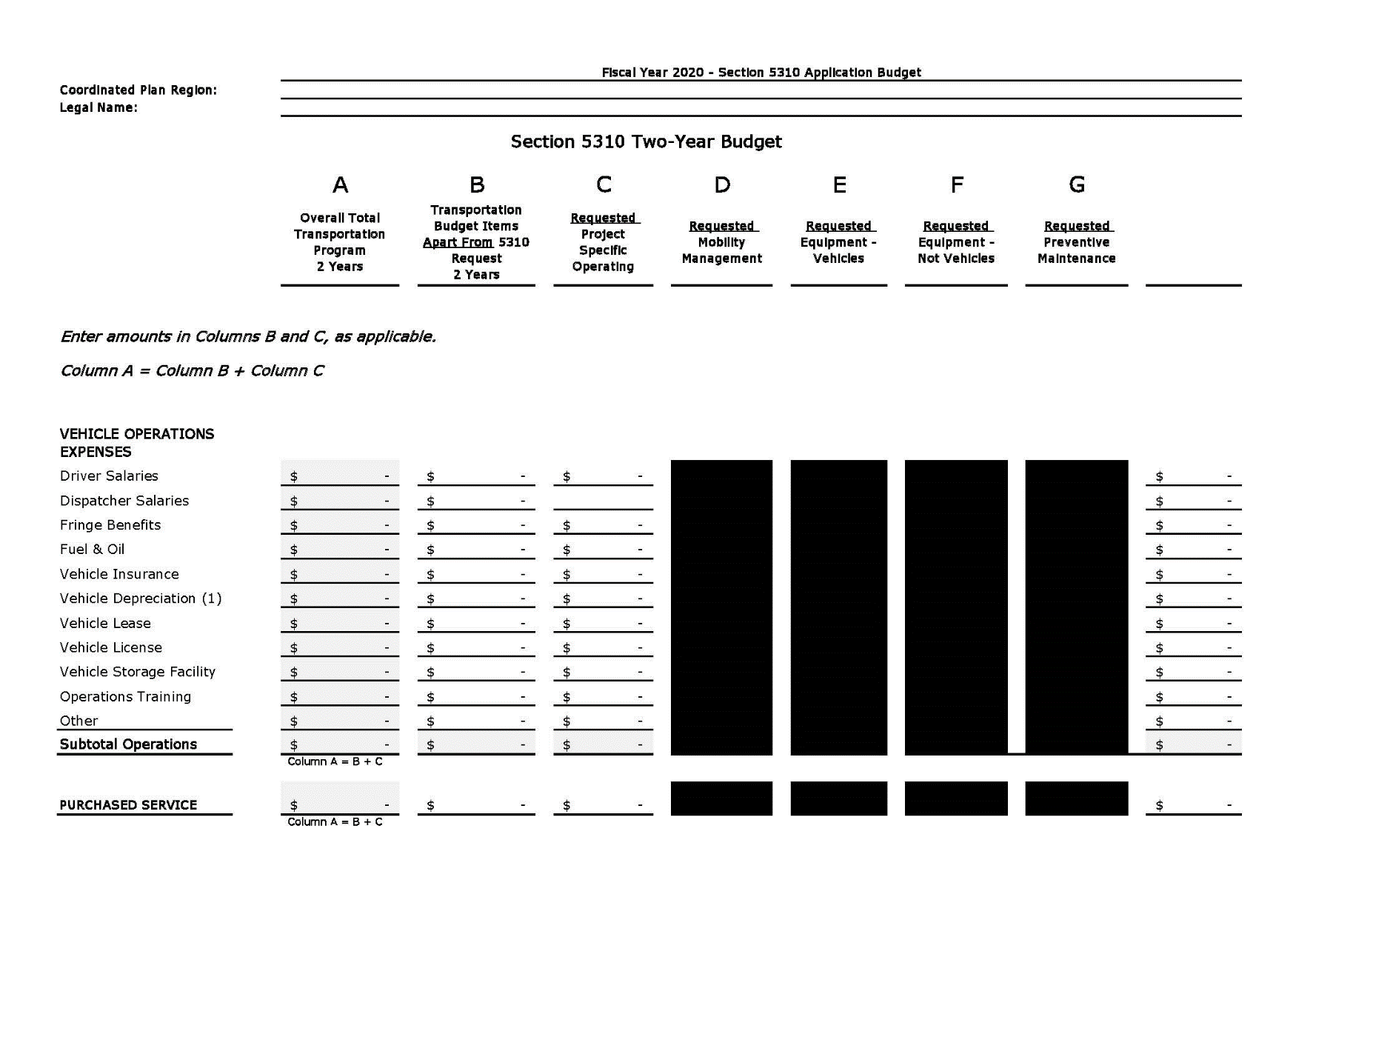

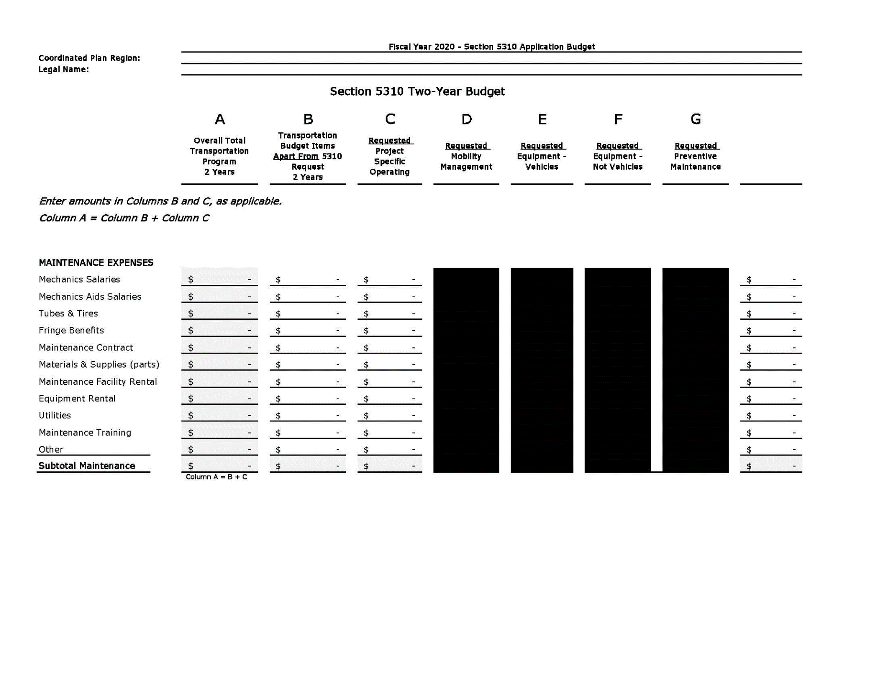

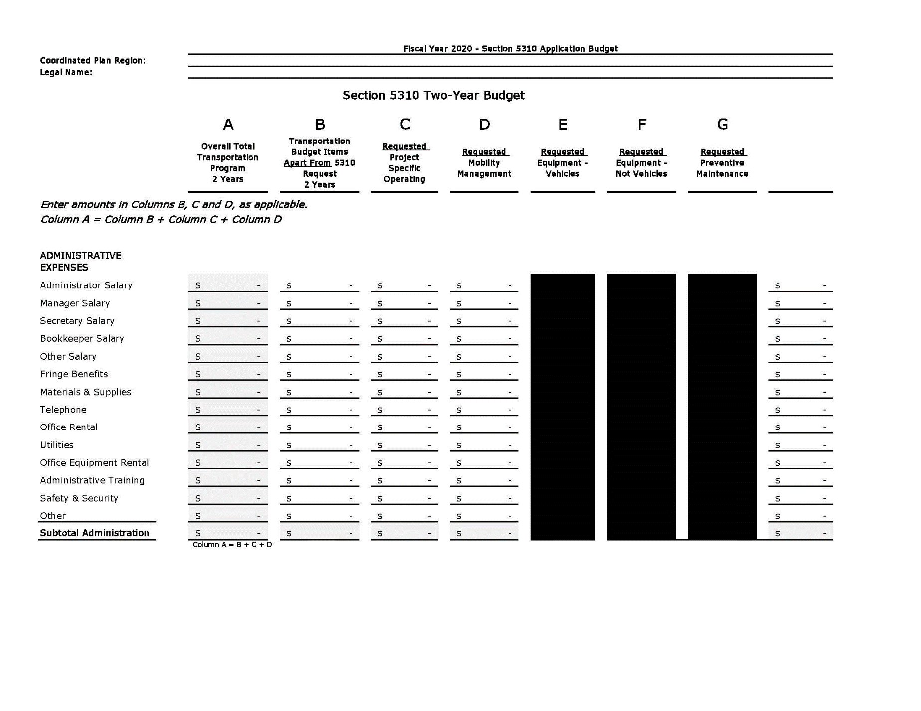

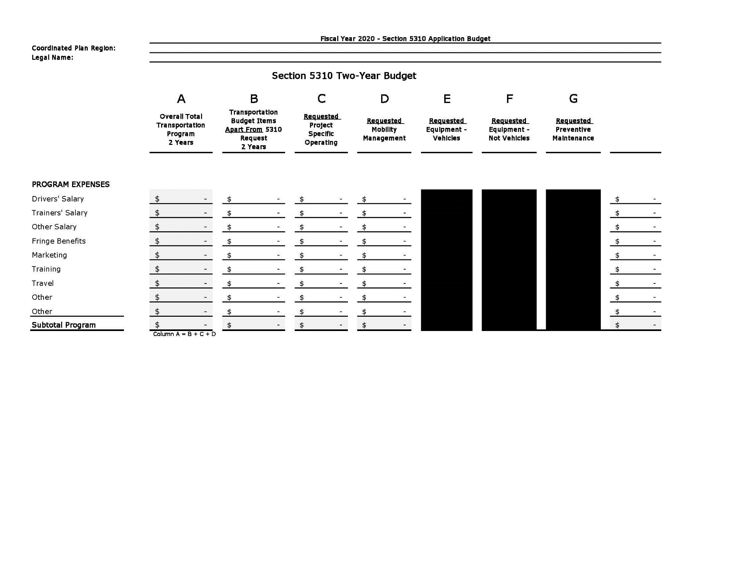

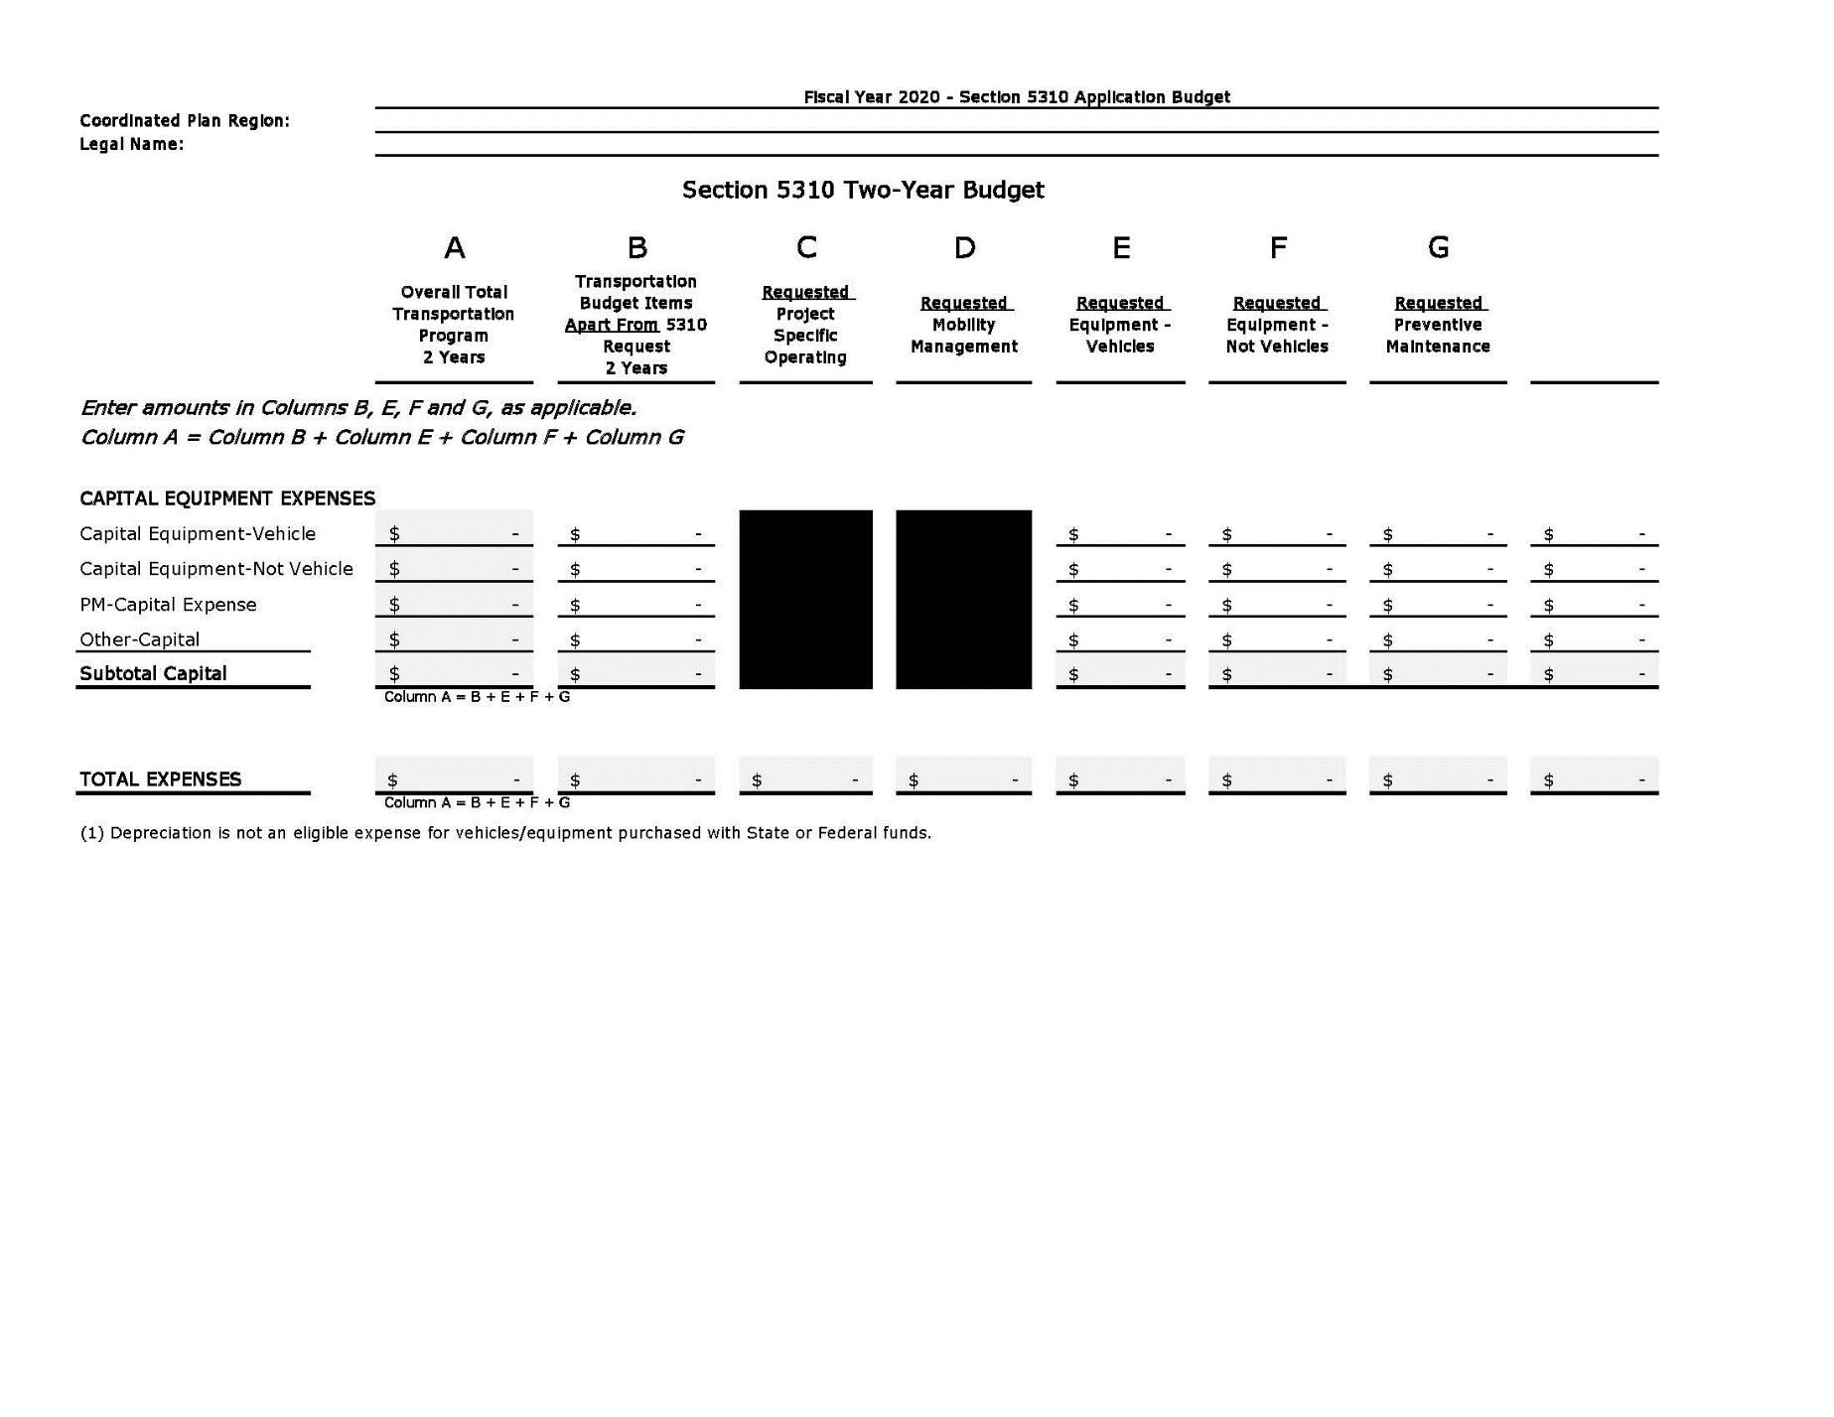

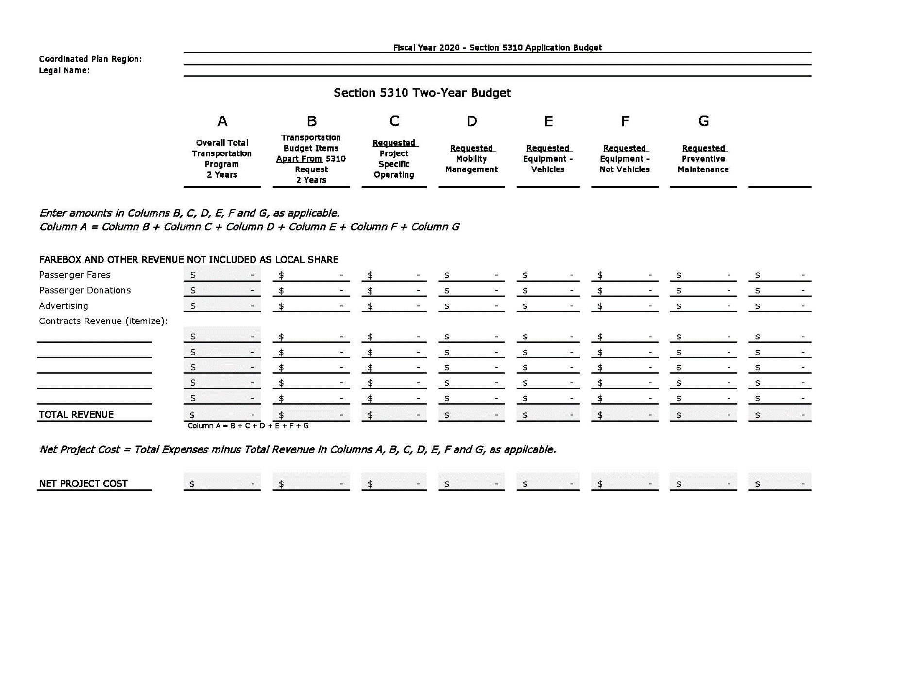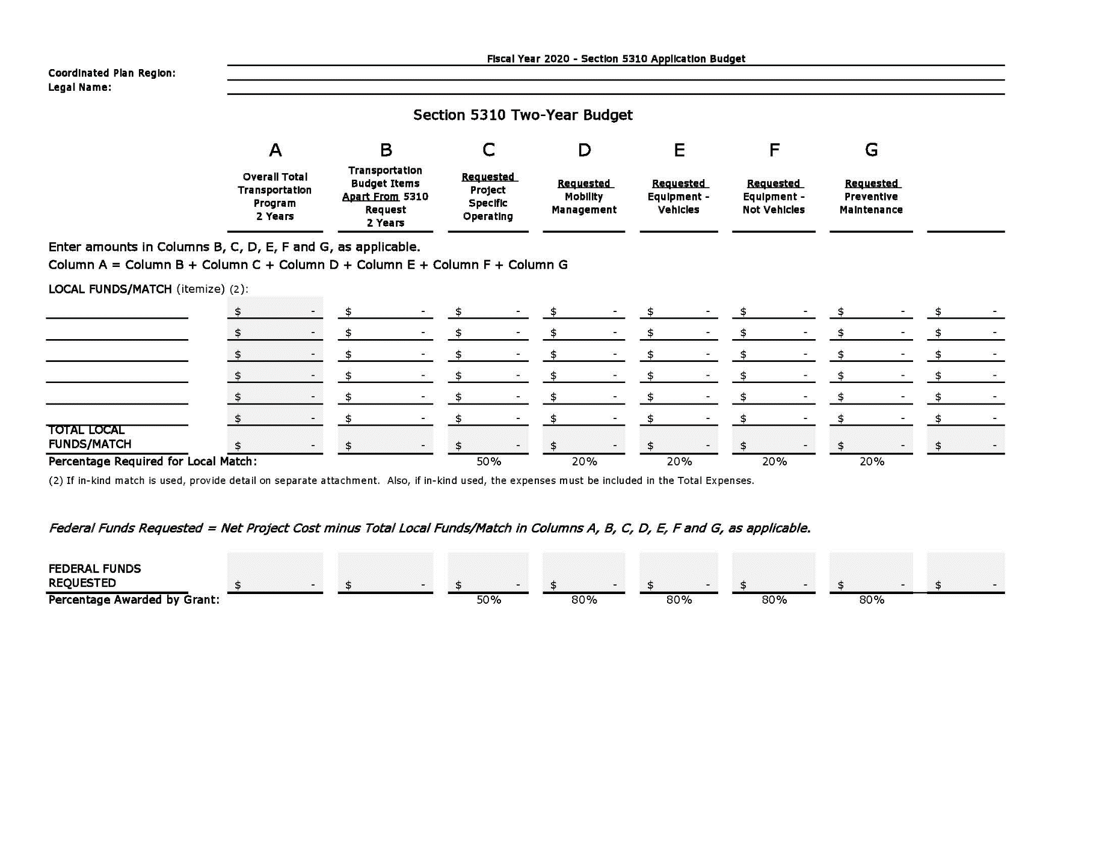

3. **MAINTENANCE PLAN**

Do you have a written maintenance plan? ________ YES ________ No

If Yes, please attach a copy.

If No, describe the maintenance program for vehicles used in providing transportation services. It is required that you develop a written maintenance plan.

Describe arrangements used for maintenance (i.e. in-house, contract, county, etc.).

Agencies that operate vehicles with a seating capacity of 16 passengers or more including the driver are subject to the Maryland Preventative Maintenance Program (PM). If you are subject to the PM Program; attach a sample of the certification kept on each vehicle.

4. **DRIVER TRAINING**

Describe your agency's driver training procedures. Indicate if your agency has a structured training program including defensive driving, safety inspection, passenger assistance, etc. How much training is provided and how often?

Provide a copy of your training schedule and curriculum.

**THIS PAGE INTENTIONALLY LEFT BLANK**

**PART II**

**CERTIFICATIONS AND ASSURANCES**

**PART II**

**Complete the standard requirements and assurances, inserting the necessary forms at the back of this application.**

1. **Assurances**

* **FTA Assurances and Certifications**
* **Link to FY 2018 FTA Certifications and Assurances:**

[**https://www.transit.dot.gov/funding/grants/grantee-resources/fta-fiscal-year-2018-certifications-and-assurances**](https://www.transit.dot.gov/funding/grants/grantee-resources/fta-fiscal-year-2018-certifications-and-assurances)

* **Authorizing Resolution**
* **Opinion of Counsel**
* **Civil Rights**
* **Project Assurances**
* **Coordination Assurances**
* **Lobbying Certification**

1. **Private Non-Profit Status**
2. **Regional Coordinating Body or Metropolitan Planning Organization Certificate of Endorsement**
3. **Procedures for Notifying all Transportation Providers**

* **Operator Notification Certification**

1. **Appendices**

* **List of Planning Offices**
* **List of FTA Public Transportation and Statewide Special Assistance Program (SSTAP) Grants in Maryland**
* **List of all other Human Services Transportation Providers**

**PLEASE NOTE:**

**TYPE THE NAME OF YOUR ORGANIZATION IN EACH BLANK SPACE ON THE FOLLOWING PAGES, USE THE ASSURANCE FORMS PROVIDED.**

**DO NOT RETYPE**

SAMPLE: Authorizing Resolution

**PUBLIC TRANSPORTATION PROGRAM RESOLUTION**

(Name of Authorizing Body)

WHEREAS, the Maryland Transit Administration is the designated recipient in Maryland for grants under the Federal Transit Act; and

WHEREAS, the Maryland Transit Administration will apply for a grant from the US Department of Transportation, Federal Transit Administration and receives funds from the Maryland General Assembly to provide assistance for public transportation projects; and

WHEREAS, the purpose of the Section 5310 program is to improve mobility for seniors and individuals with disabilities throughout the country, by removing barriers to transportation services and expanding the transportation mobility options available. Toward this goal, FTA provides financial assistance for transportation services planned, designed, and carried out to meet the special transportation needs of seniors and individuals with disabilities in all area.

WHEREAS, the Maryland Transit Administration has been designated as the State agency with principle authority and responsibility for administering the Section 5310 Program for small urbanized and rural areas; and

WHEREAS, (Legal Name of Applicant) hereby assures and certifies that it will comply with the Federal and State statutes, regulations, executive orders, and all small administrative requirements related to the applications made to and grants received from the Federal Transit Administration, as well as the provisions of Section 1001 of Title 18, U.S.C.

NOW, THEREFORE, be it resolved that the (Authorized Official’s Title)* of (Name of Applicant’s Governing Body) is hereby authorized to submit a grant for Federal and State funding, provide the required local match, make the necessary assurances and certifications and be empowered to enter into an agreement with the Maryland Transit Administration to provide public transportation services.

I ( Certifying Official’s Name)* (Certifying Official’s Title) do hereby certify that the above is true and correct copy of an excerpt from the minutes of a meeting of the (Name of Applicant’s Governing Board) duly held on the day of , .

________________________________________________________

Signature of Certifying Official Date

**SAMPLE**

**OPINION OF COUNSEL**

Name of Recipient Address of Recipient

Dear (Responsible Official for Recipient):

This communication will serve as the requisite opinion of counsel to be filed with the Federal Transit Administration, United States Department of Transportation, in connection with all applications of (Recipient) for financial assistance pursuant to the provisions of the Federal Transit Act (the "Act") for planning, capital, training, demonstration, and/or operating assistance project(s). The legal authority for (Recipient's) ability to carry out planning, capital, training, demonstration, and/or operating assistance projects directly, by lease, contract, or otherwise is set forth below:

1. (Recipient) is authorized under (cite and quote from legal authority) to provide and assist public transportation by acquisition, construction and operation of existing or additional transit facilities. This assistance may be provided directly by (Recipient) or be lease arrangements with other parties.

2. The authority of (Recipient) to provide for its share of project funds is set forth in (cite source and provide a copy of, for example, local ordinance passed by City Council making local funds available.)

3. I have reviewed the pertinent Federal, State and local laws, and I am of the opinion that there is no legal impediment to your making applications for financial assistance pursuant to the Act. Furthermore, as a result of my examination, I find that there is no pending or threatened litigation for other any which might in any way adversely affect any proposed project(s), or the ability of (Recipient) to carry out such projects.

Sincerely,

Legal Counsel

**CIVIL RIGHTS INFORMATION**

As a condition of receipt of funding from Section 5307, 5310, 5311, 5316 and/or 5317 of the Federal Transit Act, information is needed from you on the implementation of Title VI, Civil Rights. You must submit the following as part of your application.

1. **Lawsuits or Complaints**

Attach to this certification a list of any active lawsuits or complaints naming your agency which allege discrimination on the basis of race, color, or national origin with respect to service or other transit benefits. The list should include; the date the lawsuit or complaint was filed, a summary of the allegation, the status of the lawsuit or complaint, including whether the parties to a lawsuit have entered into a consent decree.

__________ Check here if no such lawsuits or complaints have occurred within the past year, a Statement to this effect must be submitted.

2. **Federal Financial Assistance**

Attach a description of all pending applications for financial assistance, and all financial assistance currently provided by other Federal agencies.

3. **Civil Rights Compliance Reviews**

Attach a summary of all civil rights compliance review activities conducted in the last three years. The summary should include; the purpose or reason for the review, the name of the agency or organization that performed the review, a summary of the findings and recommendations of the review, a report on the status and/or disposition of such findings and recommendations.

__________ Check here if a summary of all civil rights compliance review activities is not needed.

This review would be included as part of your A-128 or A-133 Single Audit or Triennial Review or conducted by the U.S. Office of Civil Rights, Federal Transit Administration.

(Signature of authorized official & date)

(Print authorized official’s name)

(Applicant’s title)

**Maryland Department of Transportation**

**Maryland Transit Administration**

**Maryland Section 5310 Program**

**PROJECT ASSURANCES**

1. For applications for all capital projects, I certify that the 20% local contribution will be available when required, in the form of cash or certified check. I understand that for non-vehicle capital projects the maximum amount available for reimbursement from the MDOT MTA will be 80%. For all projects in this application, I certify that the local match will be provided from sources other than Federal DOT funds. (Federal Community Development Block Grant, Revenue Sharing, and Appalachian Regional Commission funds may be used.)

2. I have reviewed the foregoing estimates of operating expenses and revenues, and to the best of my knowledge, these Statements are reasonable, and the proposed project is within the financial capability of the organization to operate. I understand that the maximum amount for reimbursement from the MDOT MTA will be 50%.

3. I certify that any vehicles purchased on behalf of________________________________________ under the Section 5310 Program in Maryland will not be used in the transportation of school pupils to and/or from educational facilities defined and recognized by the Maryland Department of Education. I further certify that said vehicles will be utilized in full compliance with program guidelines and regulations, and in general accordance with the plan as approved in this application.

4. I certify that __________________________________is incorporated in the State of Maryland as a private, non-profit organization; and furthermore, that said organization is currently in good standing with the Maryland Department of Assessments and Taxation.

5. I certify that equipment purchased under this Federal grant program on behalf of _______________________ will be maintained in accordance with the maintenance and inspections schedules provided by the manufacturer.

6. I certify that based on my experience with and a review of the organization's records, that the organization has the requisite fiscal and managerial capability to operate the project.

7. I certify that vehicles purchased under this Federal grant program on behalf of _____________________________________ will, to the extent practical, be used for coordination with other non-profit organizations.

8. I certify that the services provided or offered to be provided by existing public or private transit or paratransit operators are unavailable, insufficient, or inappropriate to meet the special needs of the seniors and individuals with disabilities proposed to be served by the assistance sought under this application.

9. Verification

I am an officer of the non-profit organization applying herewith and am authorized to make this verification on its behalf. The Statements and certifications in the foregoing document are true of my own knowledge.

I declare that the foregoing is true and correct.

Signature of Authorized Official_________________________

Name (printed) _______________________________________

Title_________________________­­­­­­­­­­­­­­­­­_______________________

Date________________________________________________

**COORDINATION ASSURANCE**

The ____________________________________________(recipient) assures, in accordance with the requirements of Section 5310 (b)(5) of Federal Transit Laws, Title 49, United States Code, Chapter 53, as amended, that the program to be assisted under this grant application provides for the maximum feasible coordination of its transportation services with transportation services assisted by other Federal sources.

______________________________________________

Signature of Authorized Official

______________________________________________

Name (printed)

______________________________________________

Title

______________________________________________

Date

CERTIFICATION OF RESTRICTIONS ON LOBBYING

I, _____________________________________________ (Authorized Person) hereby certify to the Maryland Transit Administration of the Maryland Department of Transportation, on behalf of ______________________________________ (Applicant-Grantee) that to the best of my knowledge and belief:

1. No Federal appropriated funds have been or will be paid by or on behalf of the Applicant to any person to influence or attempt to influence an officer or employee of any Federal agency, a Member of Congress, an officer or employee of Congress, or an employee of a Member of Congress regarding the award of Federal assistance, or the extension, continuation, renewal, amendment, or modification of any Federal assistance agreement; and

a. If any funds other than Federal appropriated funds have been or will be paid to any person to influence or attempt to influence an officer or employee of any Federal agency, a Member of Congress, an officer or employee of Congress, or an employee of a Member of Congress in connection with any application for Federal assistance, the Applicant assures that it will complete and submit Standard Form-LLL, “Disclosure Form to Report Lobbying,” including information required by the instructions accompanying the form, which form may be amended to omit such information as authorized by 31 U.S.C. 1352.

b. The language of this certification shall be included in the award documents for all subawards at all tiers (including subcontracts, subgrants, subagreements, contracts under grants, loans, and cooperative agreements).

2. The Applicant understands that this certification is a material representation of fact upon which reliance is placed by the Federal Government and that submission of this certification is a prerequisite for providing Federal assistance for a transaction covered by 31 U.S.C. 1352. The Applicant also understands that any person who fails to file a required certification shall be subject to a civil penalty of not less than $10,000 and not more than $100,000 for each such failure.

By: _____________________________________

Signature of Authorized Official & Date

_____________________________________

Name (print)

___________________________________

Title**II. NON-PROFIT STATUS**

Insert one of the following as evidence of your organizations non-profit status:

1. A copy of the Articles of Incorporation filed with the Maryland Department of Assessments and Taxation, or

2. A copy of the determination letter from the U.S. Internal Revenue Service documenting your organization's private, non-profit status.

Although a copy of either of the above is acceptable, submission of Item 2 (above), IRS documentation, greatly expedites the State and FTA reviews of your non-profit status.

The documents submitted for this part of your application must reflect the current and correct name of your organization.

**III. Regional Coordinating Body Certificate of Endorsement**

A certificate of endorsement by the appropriate Coordinating Body and or Metropolitan Planning Organization (MPO) is required for all applicants in order to be considered for Section 5310 funding in Maryland.

1. Applicants submit one hard copy and one electronic copy via flash drive of Part I to the appropriate Regional Coordinating Body and or MPO by **November 30, 2018.**

* Shore Transit (Somerset, Wicomico, Worcester)
* Maryland Upper Shore Transit - MUST (Caroline, Cecil, Dorchester, Kent, Queen Anne's, Talbot)
* Southern Maryland Regional Transportation Coordination Committee - Calvert, Charles and

St. Mary's counties)

* Tri County Council of Western Maryland (Allegany, Frederick, Garrett and Washington counties)
* Baltimore Metropolitan Council (Anne Arundel, Baltimore, Carroll, Harford, Howard counties)
* Washington Metropolitan Council of Governments (Montgomery and Prince George’s counties)

2. A technical subcommittee of the Regional Coordinating Bodies reviews applications to ensure transportation services are coordinated to the maximum extent feasible and the projects are included in or derived from the region’s most recent human service transportation coordination plan. Applications are reviewed based on:

* Applicant's knowledge of other providers purpose, capabilities, and areas served;
* Degree to which proposed project demonstrates transportation coordination with local or regional service agencies and existing transit and paratransit providers;
* Extent of coordination of services, maintenance, fuel, and training;
* Percentage of operating time other agencies have use of applicant's vehicles;
* Existence of contracts or agreements for purchasing or providing transportation services;
* Applicant's involvement in local or regional coordination efforts.

3. The subcommittee makes recommendation to the full Coordinating Body. The Coordinating Body reviews subcommittee's recommendation and determines applications for endorsement. Applications are not ranked but are given an endorsement or non-endorsement. A debriefing from the Regional Coordinating Body may be requested by any applicant that receives a non-endorsement.

4. The Coordinating Body presents endorsed projects to MDOT MTA and the SCCHST Review Subcommittee by December 31, 2018.

5. The SCCHST Review Subcommittee considers the Regional Coordinating Bodies endorsements as part of award process.

6. The SCCHST Review Subcommittee will meet to review and rank submitted projects on February 20, 2019.

Maryland Department of Transportation

Maryland Transit Administration

Section 5310 Program

##### REGIONAL COORDINATING BODY OR METROPOLITAN PLANNING ORGANIZATION CERTIFICATE OF ENDORSEMENT

for

Transportation Projects of Private, Non-Profit Organizations

Applying for Assistance in Maryland under Section 5310 of the

Fixing America’s Surface Transportation Act (FAST Act)

State FY 2020 and FY 2021

This serves as recognition and certification of the transportation service to be provided to seniors and individuals with disabilities by (Applicant Agency) _____________________ as an essential service for the Region and is coordinated to the maximum extent feasible with other transportation services. The services proposed are found to be necessary to meet area transportation needs, are included in or derived from the most recent regional human service transportation coordination plan, and therefore this agency’s application for FY 2020-2021 Section 5310 funding in Maryland is endorsed.

Regional Coordinating Body or

Metropolitan Planning Organization: ______________________________________________________

Planning Official: (typed) _______________________________________________________________

Signature of Above Official: _____________________________________________________________

Title: ____________________________________________ Date: ______________________________

_______ Consistent with State Coordination

_______ Inconsistent with State Coordination

**V. PROCEDURES FOR NOTIFYING ALL TRANSPORTATION PROVIDERS AND INTERESTED CITIZENS**

The following procedures and schedules must be followed in notifying all existing transportation providers in your agency's proposed Section 5310 service area and private citizens.

**1. Public Notice - Must be published by October 29, 2018**

Your organization must publish a public notice in a local area wide newspaper briefly describing the transportation services your organization is proposing to provide with the vehicle or equipment for which you are applying in this application.

The required notice form follows these instructions. This notice must be published by **October 29, 2018.** This will give your agency sufficient time to respond to any comments received**. When you place the public notice in the newspaper, ask the paper to send you a certified copy of the public notice to be included in your Section 5310 application.**

**REQUIRED PUBLIC NOTICE FORMAT**

The (name of Organization), a private non-profit organization located in (Name of County) County, is applying to the U.S. Department of Transportation, Federal Transit Administration through the State Coordinating Committee for Human Services Transportation of the State of Maryland for financial assistance to aid in the purchase of (Description of project) for (total funds applied for in application) designed to meet the special transportation needs of seniors and individuals with disabilities.

The (Name of Organization) plans to provide transportation services as follows:

____________________________________________________________________________________

____________________________________________________________________________________

____________________________________________________________________________________

____________________________________________________________________________________

The detailed service plan is available for review at (location of office) from (hours and dates). Any private citizen, public or private transit or paratransit operator wishing additional information or desiring to submit comments on the project applied for or on the performance of (your agency's name) may be obtained by calling (area code and telephone number of agency office).

**2. Written Notification - Mail by October 29, 2018**

To ensure that the Section 5310 Program does not fund projects that will duplicate or compete with existing services, all transportation providers in the proposed service area of the Section 5310 grant application must be notified of the submittal in writing. All providers in the proposed service area must be informed of the proposed service so they can submit comments to you on your performance. This notification must be postmarked using regular mail in a time period sufficient for transportation providers to review your application for capital funds and comment upon the intended service prior to submission to the ICST. All such comments and your response must be included as part of the application.

a. Send the letter to operators in your service area (letter follows). Notice must be mailed by **October 29, 2018**

Operators to be notified include:

¨ Public transit operators, particularly those funded under Federal Transit Administration (FTA) Section 5307 or Section 5311 programs or the former Section 5316 or 5317 programs;

¨ Private transit and paratransit operators such as charter bus and taxi operators;

¨ Social service operators, particularly those funded previously under the FTA Section 5310 or other Federal programs;

¨ Transit operators funded by the Maryland Statewide Special Transportation Assistance Program (SSTAP);

For your convenience, lists of past recipients of FTA and Section 5310 grants are provided in the Appendix. Private and public operators can be identified by using resources such as the telephone company Yellow Pages or through internet searches, under heading of "Bus Lines", and/or "Taxicabs". For other social service providers, county or city social service offices and the county or city transportation planner may know of such operators. REMEMBER, YOUR ORGANIZATION NEED CONTACT ONLY THOSE OPERATORS THAT PROVIDE SERVICE IN YOUR AREA.

**Submit in Part II of the Application:**

1. A dated sample copy of the letters sent to existing private operators advising them of your agency's intent to operate the proposed service;
2. The operator Notification Certification listing the mailing list for all operators notified;
3. All forums, meetings, hearings. or other opportunities for involving the private sector early in the project development process; describe your Citizens Advisory Committee;
4. Copies of all comments received and your responses to the comments from both the transportation operators and the private sector that were offered for consideration.

Maryland Department of Transportation

Maryland Transit Administration

Maryland Section 5310 Program

#### OPERATORS NOTIFICATION CERTIFICATION

Letters requesting comments on the proposed project were sent to each of the transit and paratransit operators, both public and private, listed below who are known to be providers of transportation in our service area.

Comments

Received*

Operator Contacted Address Yes No

I certify that I have made a good faith effort to notify all transit and paratransit operators, both public and private, in my service area, and they have been contacted concerning the transportation service we propose to provide for the elderly and persons with disabilities.

______________________________________________

Signature of Authorized Official

______________________________________________

Name (printed)

______________________________________________

Title

______________________________________________

Date LETTER OF NOTIFICATION

TO BE SENT TO LOCAL TRANSIT AND PARATRANSIT OPERATORS

BY THE 5310 APPLICANT

Company Name:_______________________

Date:__________________

Address: _____________________________

Salutation:

The (Applicant Agency), a private, non-profit organization located in (Name of County) County, is applying to the U.S. Department of Transportation, through the State Coordinating Committee for Human Services Transportation of the State of Maryland for financial assistance to aid in the purchase of (Description of Project) designed to meet the special transportation needs of seniors and individuals with disabilities. For capital projects, eighty percent (80%) of the cost of this purchase is funded by the Federal Transit Administration (FTA) under the provisions of Section 5310 of the Federal Transit Act. For operating projects, fifty percent (50%) of the net operating costs are funded by the Federal Transit Administration (FTA). The remaining costs are provided by the local applicant organization. Funds available under this Federal program are limited in Maryland to private, non-profit organizations.

If a vehicle application: The (Applicant Agency is applying for financial assistance to aid in the purchase of (Number and types of Vehicles or Equipment) designed to meet the special needs of (Types of Persons to be Served, i.e., seniors, individuals with disabilities, etc.) in (General Service Area). This (Vehicle or Equipment) will be used to (Briefly Describe Proposed Service).

Federal guidelines require that all existing local transportation operators must be given an opportunity to comment on the proposed project in the application for funds or on our service plan, should they so desire. It is not the intent of the State of Maryland when making funds available to non-profit agencies to preclude possible participation by private operators. It is the desire of the State to effectively utilize available Federal funds to improve the transportation services to seniors and individuals with disabilities through projects sponsored by private, non-profit organizations, where such services are currently unavailable, insufficient or inappropriate.

Comments must be received no later than **November 30, 2018**. If you intend to make comments on the proposed project or service plan, please send your comments in writing directly to us. Send a copy of your comments to **Ms. Nancy Huggins, Program Manager, Maryland Transit Administration, 8th Floor, 6 St. Paul Street, Baltimore, MD 21202**.

If you should need any additional information on our service proposal, please contact us.

(Name and Title)

(Applicant Agency)

(Address and Telephone )

**3. Receipt of Comments from Operators/Private Citizens – November 30, 2018**

All comments must be submitted to the FTA Section 5310 applicant by

November 30, 2018.

**4. Review Comments from Providers and Private Citizens - Must be completed by December 14, 2018**

When the comments are returned to you, review them carefully to determine which, if any, of the comments could affect your application submittal. The FTA requires that before you submit your final application, you must consider the views and comments of private transportation providers and citizens and if appropriate modify your application. Your organization must respond to the individual or provider making the comment, **in writing**, that their comments were received.

|  |
| --- |
| **FY 2020 – FY2021 Section 5310 Application Checklist** |
| ***PART I*** |
| General Information  General Agency Information  Extent and Urgency of Agency Needs  Agency Services Chart  Project Coordination  Service Contracts  Vehicle Utilization  Vehicle Replacement (if applicable)  Vehicle Utilization Plan  Equipment Inventory  Source of Local Contributions  Estimated Cost and Seating Configuration  Transportation Program Operating Budget Worksheet  Maintenance Plan  Driver Training |
| ***PART II*** |
| General Certifications & Assurances  Authorizing Resolution  Opinion of Counsel  Project Assurances  Civil Rights Certification  Coordination Assurance  Proof of your Organization’s Non-Profit Status  Regional Coordinating Body Certificate of Endorsement  Certified Public Notice  Written Notification Section  Sample letter sent to contact existing operators and mailing list  Operator Notification Certification  Description of Private Sector Involvement  Copies of any comments received and your organization’s responses |

When you complete your application:

Make **five (5) copies of Part I** of your application plus original and an electronic copy.

* Use supplied forms
* Use binder clips to bound your application
* Divide sections with colored paper
* Keep grant pages in order and make sure that the pagination is correct
* Mark the original

Make **one (1) copy of Part II** plus original and an electronic copy.

Send or **bring** the originals and the copies no later than **January 11, 2019 , 3:00 p.m.**  to:

**Nancy Huggins**

**Program Manager**

**Maryland Transit Administration**

**6 St. Paul Street, 8th Floor**

**Baltimore, Maryland 21202**

**APPENDICIES**

**VI** **APPENDICES**

1. List of Regional Coordinating Bodies
2. List of Public Transit Grant Recipients in Maryland
3. List of Active Section 5310 Mailing List
4. List of Regional Planners

**REGIONAL COORDINATING BODIES**

**Regional Coordination Bodies**

Maryland Upper Shore Transit Scott Warner

(Caroline, Cecil, Dorchester, Kent Mid Shore Regional Council

Queen Anne’s, Talbot) 8737 Brooks Drive

Easton MD 21601

410-829-0457

Tri County Council for the Brad Bellacicco

Lower Eastern Shore Tri-County Council LES

(Somerset, Wicomico, Worcester) 31901 Tri-County Way

Suite 133

Salisbury, MD 21804

410-341-8951

Southern Maryland Regional Yolanda Hipski, AICP RLA

(Calvert, Charles, St. Mary’s) Regional Transit Coordinator P.O. Box 745

15045 Burnt Store Road

Hughesville MD 20637

301-274-1922 ext. 825

Western Maryland Ryan Davis

(Frederick, Allegany, Garrett Economic Development Planner

and Washington Counties) Tri-County Council for Western MD

1 Technology Drive, Suite 1000

Frostburg, MD 21532

301-689-1300

**Metropolitan Planning Organizations**

Baltimore Region Baltimore Metropolitan Council

(Annapolis, Anne Arundel, Baltimore, Regina Aris

Carroll, Harford, Howard Counties and Offices @ McHenry Row

Baltimore City) 1500 Whetstone Way, Suite 300

Baltimore, MD 21230

Washington Region Metropolitan Washington Council of

(Montgomery and Prince Governments

George’s Counties) Lynn Winchell-Mendy

777 North Capitol Street, N.E.

Washington, D.C. 20002

**THIS PAGE INTENTIONALLY LEFT BLANK**

**PUBLIC TRANSIT GRANT RECIPIENTS**

### PUBLIC TRANSIT GRANT RECIPIENTS

### ALLEGANY COUNTY

Elizabeth Robinson-Harper

Allegany County

1000 Lafayette Street

Cumberland, MD 21502

301-722-6360

### CITY OF ANNAPOLIS

J. Rick Gordon

Annapolis Department of Public Transportation

308 Chinquapin Round Road

Annapolis, MD 21401

410-263-7964

### ANNE ARUNDEL COUNTY

Ramond Robinson

Office of Transportation

2664 Riva Road, 3rd Floor, MS 6600

Annapolis, MD 21401

410-222-7440

**BALTIMORE CITY**

Colby McFarland

Department of Transportation

417 E. Fayette Street

Baltimore, MD 21201

410-545-6020

### BALTIMORE COUNTY

Karen Bode

Baltimore County Department of Aging

611 Central Avenue

Towson, MD 21204

410-887-8220

### CALVERT COUNTY

Sandra Wobbleton

Calvert Co. Office of Transportation

175 Main Street

Prince Frederick, MD 20678

410-535-4268

**CARROLL COUNTY**

Jeffrey Castonguay

Department of Public Works

225 North Center Street, #221

Westminster, MD 21157

443-386-2170

### CECIL COUNTY Suzanne Kalmbacher, Transit Chief

Cecil County Transit

### 200 Chesapeake Blvd., Suite 2500 Elkton, MD  21921 410-996-5295

### CHARLES COUNTY

Jeffrey Barnett, Chief of Transit

Department of Planning & Growth Management, Transit Division

Charles County Government

200 Baltimore Street

LaPlata, MD 20646

301-934-0102

### DORCHESTER COUNTY

Santo Grande, Director

Delmarva Community Services

2450 Cambridge Beltway – P.O. Box 637

Cambridge, MD 21613

410-221-1900

### FREDERICK COUNTY

Nancy Norris, Director

TransIT Services of Frederick County

1040 Rocky Springs Road

Frederick, MD 21702

301-600-2065

### GARRETT COUNTY

Mike Hill, Director of Transportation

Garrett County CAC, Inc

104 East Center Street

Oakland, MD 21550

301-533-9010

### HARFORD COUNTY

Gary Blazinsky, Administrator

Harford County Transit

1311 Abingdon Road

Abingdon, MD 21009

410-612-1620

### HOWARD COUNTY

Clive Graham

Howard County Office of Transportation

George Howard Building

3430 Courthouse drive

Ellicott City, MD 21043

410-313-1655

### KENT, CAROLINE AND TALBOT COUNTIES

Santo Grande

Executive Director

Delmarva Community Services

2450 Cambridge Beltway, P.O. Box 637

Cambridge, MD 21613

410-221-1900

### MONTGOMERY COUNTY

Dan Hibbert, Chief

Division of Transit Services

Executive Office Building

101 Monroe Street, 5th Floor

Rockville, MD 20850

240-777-5800

### PRINCE GEORGE’S COUNTY

### D’Andrea Walker, Chief

Prince George’s County

Department of Public Works and Transportation

9400 Peppercorn Place, Suite 300

Landover, MD 20785

301-883-5656

### QUEEN ANNE’S COUNTY

Catherine Willis, Director

Queen Anne’s County Department on Aging

316 Safety Drive

Centerville, MD 21617

410-758-0848

### SOMERSET COUNTY

Sheree Marshall

Director

Somerset County Office on Aging

11916 Somerset Avenue

Princess Anne, MD 21853

410-651-3400

### ST. MARY’S COUNTY

MaryAnne Blankenship

St. Mary’s Transit System

44829 St. Andrews Church Road

California, MD 20619

301-863-8400

### TOWN OF OCEAN CITY

Mark Rickards

Town of Ocean City Transportation Department

204 65th Street

Ocean City, MD 21842

410-723-2174

### WASHINGTON COUNTY

Kevin Cerrone

Director

Washington County Commuter

1000 West Washington Street

Hagerstown, MD 21740-5212

240-313-2750

### WICOMICO/WORCESTER COUNTY

Brad Bellacicco

Director

31901 Tri-County Way

Suite 133

Salisbury, MD 21804

410-341-8951

**THIS PAGE INTENTIONALLY LEFT BLANK**

**SECTION 5310 MAILING LIST**

**TRANSPORTATION SERVICE PROVIDERS**

Allegany

Memorial Hospital & Home Health Services

600 Memorial Avenue

Cumberland MD 21502

(301) 777-4127

Allegany

Friends Aware, Inc.

1601 Holland Street

Cumberland, MD 21502

301-722-7268

Allegany

Allegany County League for Crippled Children

P.O. Box 267

Cumberland MD 21502

Allegany

Allegany County Nursing Home

730 Furnace Street Extended

Cumberland MD 21502

301-777-5940

Allegany

Allegany County Human Resource Development Commission – Adult Day Care

720 Furnace Street

Cumberland, MD 21502

Allegany

Moran Manor Nursing Home

25701 Shady Lane

Westernport MD 21562

301-359-3000

Allegany

Frostburg Village Adult Medical Daycare

1 Kaylor Circle

Frostburg MD 21532

Allegany

Allegany County Nursing Home

730 Furnace Branch Street

Cumberland MD 21502

301-777-5941

Allegany

Housing Authority of Allegany County

701 Furnace Street, Suite One

Cumberland MD 21502

Allegany

Western Maryland Health Systems

300 East Oldtown Road

Cumberland MD 21502

Allegany

Blind Industries & Services of MD

322 Paca Street

Cumberland MD 21502

Allegany

Frostburg Village of Allegany County

One Kaylor Circle

Frostburg MD 21532

301-689-2459

Allegany

Archway Station

45 Queen Street

Cumberland MD 21502

301-777-1700

Allegany

Allegany County United Way

101 S Centre Street

Cumberland MD 21502

301-722-2700

Allegany

Horizon Goodwill Industries, Inc.

14515 Pennsylvania Avenue

Hagerstown, MD 21742

301-733-7330

Allegany

Salem Children's Trust-Frostburg

605 Salem Drive

Frostburg MD 21532

301-689-8176

Spectrum Support, Inc.

27 East Industrial Boulevard

Cumberland, MD 21502

301-724-1690

Western Maryland Health System

Regional Medical Center

12500 Willowbrook Road

Cumberland, MD 21502

Anne Arundel

Opportunity Builders, Inc.

8855 Veterans Highway

Millersville, MD 21108

Anne Arundel

Arundel House of Hope

514 N Crain Highway, Suite K

Glen Burnie MD 21061

410-863-4888

Anne Arundel

Providence Center, Inc.

930 Point Pleasant Rd

Glen Burnie MD 21060

410-766-2212

Anne Arundel

Annapolis Housing Authority

1217 Madison Street

Annapolis MD 21403

410-267-8000

Anne Arundel

Arundel Lodge, Inc.

2600 Solomons Island Road

Edgewater MD 21037

443-433-5900

Anne Arundel

Woods Adult Day Care Center

8227 Cloverleaf Drive, Suite 300

Millersville MD 21108

301-987-0360

Anne Arundel

Bay Community Support Services

31168 Braverton St, Suite 300

Edgewater, MD 21037-26801401

Anne Arundel

Mr. Calvin Parker

Fairfield Nursing and Rehabilitation Center

1454 Fairfield Loop Road

Crownsville, MD 21032

410-923-6820

Anne Arundel

Anne Arundel Co. Economic Opportunity

2660 Riva Rd, Suite 200

Annapolis MD 21401

410-222-7410

Anne Arundel

City of Annapolis Housing Authority

1217 Madison Street

Annapolis MD 21403

Anne Arundel

Omni House, Inc.

P.O. Box 1270

Glen Burnie MD 21060

410-768-6777

Anne Arundel

Partners In Care

8151-C Ritchie Highway

Glen Burnie MD 21122

410-544-4800

Anne Arundel

Ms. Cheryl Richardson

Bello MaChre

7765 Freetown Road

Glen Burnie, MD 21060

443-702-3000

Anne Arundel

South County Faith Network, Inc.

6248 Shady Side Road

P.O. Box 529

Shadyside, MD 20764

410-867-1128

Anne Arundel

The Arc of Maryland

130 Lubrano Dr, Suite 212

Annapolis, MD 21401

410-571-9320

Baltimore

Associated Black Charities

2 Hamill Rd

272 N Quadrangle

Baltimore, MD 21210

410-659-0000

Baltimore

Comprehensive Housing Assistance, INC. (CHAI)

5809 Park Heights Avenue

Baltimore, MD 21215-3931

410-500-5331

Baltimore

Medstar Harbour Hospital

3001 South Hanover Street

Baltimore MD 21225

410-350-3200

BWI Business Partnership, Inc.

1306 Concourse Dr., Suite 215

Linthicum Heights, MD 21090

410-859-1000

PACT

7000 Tudsbury Road

Baltimore, MD 21244

ARC of Howard County

11735 Homewood Road

Ellicott City, MD 21042

410-730-0638

The Arc Central Chesapeake Region

931 Spa Road

Annapolis, MD 21401

410-269-1883

The Arc Northern Chesapeake Region

4513 Philadelphia Road

Aberdeen, MD 21001

Easter Seals Adult Day Services

7138 Windsor Boulevard

Baltimore, MD 21244

Gallagher Services for People with Developmental Disabilities

2520 Pot Spring Road

Lutherville-Timonium, MD 21093

410.252.4005

Goodwill Industries of the Chesapeake

222 E Redwood Street

Baltimore, MD 21202-3312

Sheppard Pratt at Howard County

9030 Route 108, Suite A

Columbia, MD 21045

Human Services Programs of Carroll County, Inc.

10 Distillery Drive

Westminster, MD 21158

Jewish Community Services

5750 Park Heights Avenue

Baltimore, MD 21215

410-466-9200

Linwood Center, Inc.

3421 Martha Bush Drive

Ellicott City, MD 21043

Prologue, Inc.

Harry and Jeanette Weinberg Center

3 Milford Mill Road

Baltimore, MD 21208

Spectrum Support, Inc.

2 Park Center, Unit 3

Owings Mills, MD 21117

Richcroft, Inc.

Executive Plaza IV

11350 McCormick Road, Suite 700

Hunt Valley, MD 21031

St. Ann Adult Day Services

3308 Benson Avenue

Halethorpe, MD 21227

410-646-0320

Baltimore

Community Services Division

Catholic Charities

320 Cathedral Street

Baltimore MD 21201

Baltimore

United Way of Central Maryland

1800 Washington Blvd, Suite 340

Baltimore MD 21230

Baltimore

Villa Maria School

2300 Dulaney Valley Road

Timonium MD 21093

Baltimore

MD. Assoc. of Non-Profit Organizations

1500 Union Ave, Suite 2500

Baltimore MD 21211

Baltimore

Resident Services Coordinator

The Shelter Foundation

111 S Calvert St, Suite 2700

Baltimore MD 21202

410-828-7185

Baltimore

My Sisters Place Lodge

111 W. Mulberry Street

Baltimore MD 21201

410-727-3523

Baltimore

Ms. Andrea Braid

Jenkins Senior Living Campus

3308 Benson Avenue

Baltimore MD 21227

410-646-0320

Baltimore

Allen AME Church

1130 West Lexington Street

Baltimore MD 21223

Baltimore

ARC of Baltimore

7215 York Road

Baltimore MD 21212

410-296-9675 ext. 5317

Baltimore

Franciscan Center

101 W 23rd Street

Baltimore MD 21218

Baltimore

Behavioral Health Administration

O'Connor Building

201 West Preston Street

Baltimore MD 21201

Baltimore

Baltimore County Community College-Dundalk

Single Step Program

7200 Sollers Point Road

Baltimore MD 21222

Baltimore

Community Behavorial Health

Association of Maryland

18 Egges Lane

Catonsville MD 21228

410-788-1865

Baltimore

The Villa

6806 Bellona Avenue

Baltimore MD 21212

410-377-2450

Baltimore

The Chimes

4815 Seton Drive

Baltimore MD 21215

Baltimore

Baltimore Jewish Council

5750 Park Heights Ave

Baltimore MD 21215

Baltimore

Alliance Inc.

8003 Corporate Drive

Baltimore MD 21236

Baltimore

Kennedy Krieger High School

3825 Greenspring Avenue

Baltimore MD 21211

Baltimore

Director

Johns Hopkins School of Medicine, AIDS

1830 Monument Street

Room 8071

Baltimore MD 21205

Baltimore

Director

St. Bernadine’s Special Education School

3814 Edmonds Avenue

Baltimore MD 21229

Baltimore

Director of Development/Marketing

The League for People with Disabilities

1111 East Cold Spring Lane

Baltimore MD 21239

Baltimore

ReVisions, Inc.

20 Winters Lane

Catonsville MD 21228

410-747-4492

Baltimore

Baltimore American Indian Center

113 South Broadway

Baltimore MD 21231

Baltimore

Echo House

1705 West Fayette Street

Baltimore MD 21223

410-947-1700

Baltimore

National Federation for the Blind

Jernigan Place

200 E Wells Street

Baltimore MD 21230

410-659-9314

Baltimore

UMD Medical System/Harbor City Unlimited

1227 W. Pratt Street

Baltimore MD 21223

410-328-8560

Baltimore

Liberty Medical Center, Inc.

2600 Liberty Heights Avenue

Baltimore MD 21215

410-393-4727

Baltimore

Johns Hopkins Bayview Medical Center

1627A Thames Street

Baltimore MD 21231

410-550-1155

Baltimore

Bethel AME Church

1300 Druid Hill Avenue

Baltimore MD 21217

Baltimore

Jewish Community Center of Greater Baltimore

5700 Park Heights Avenue

Baltimore MD 21215

410-542-4900

Baltimore

Woodburne Center

1301 Woodburne Avenue

Baltimore MD 21239

Baltimore

Maryland School for the Blind

3501 Taylor Avenue

Baltimore MD 21236-4499

410-444-5000

Baltimore

St. Luke’s United Methodist Church

2119 Gwynn Oak Avenue

Baltimore MD 21207

410-944-4111

Baltimore

Catholic Charities/Kessler Park

4230 Hollins Ferry Road

Lansdowne MD 21227

Baltimore

Mosaic Community Services Inc.

1925 Greenspring Drive

Timonium MD 21093

410-453-9553

Baltimore

Mission Helpers of Sacred Heart

1001 West Joppa Road

Baltimore MD 21204

410-823-8585

Baltimore

Mount Washington Pediatric Hospital

1708 West Rogers Avenue

Baltimore MD 21209

410-578-8600

Baltimore

St. Elizabeth's School for Special Education

801 Argonne Drive

Baltimore MD 21218

410-889-5054

Baltimore

Mercy Hospital

301 St. Paul Street

Baltimore MD 21202

Baltimore

Macedonia Baptist Church

718 West Lafayette Avenue

Baltimore MD 21217

Baltimore

St. Vincent's Villa

2600 Pot Springs Road

Timonium MD 21093

Baltimore

Johns Hopkins Bayview Medical Center

4940 Eastern Avenue

Baltimore MD 21224

Baltimore

Family & Children's Services of Central MD

4623 Falls Road

Baltimore, MD 21209

410-366-1980

Baltimore

Project PLASE

1814 Maryland Ave.

Baltimore MD 21201

410-837-1400

Baltimore

People Encouraging People, Inc.

4201 Primrose Avenue

Baltimore MD 21215

410-764-8560

Baltimore

United Cerebral Palsy of Central MD

11350 McCormick Rd, Suite 100

Hunt Valley MD 21031

Baltimore

Action In Maturity

700 W 40th Street

Baltimore MD 21211-2140

410-889-7915

Baltimore

Grace Presbyterian Church

2604 Banister Road

Baltimore MD 21215

410-521-3418

Baltimore

Pickers Gill Retirement Community

615 Chestnut Avenue

Towson MD 21204

410-842-0421

Baltimore

Mental Health Association of Maryland

1301 York Rd, Suite 505

Lutherville MD 21093

443-901-1550

Baltimore

Stella Maris, Inc.

2300 Dulaney Valley Road

Timonium MD 21093

Baltimore

Penn-Mar Organizations, Inc.

310 Freeland Rd

Freeland MD 21053-9676

Baltimore

St. Ambrose

321 East 25th Street

Baltimore MD 21218

Baltimore

Sheppard Pratt Hospital

6501 North Charles Street

Baltimore MD 21285-6815

410-938-4000

Baltimore

Mary Elizabeth Lange Center

601 East Chase Street

Baltimore MD 21202

410-244-8605

Baltimore

Glass Health Systems

3635 Old Court Road

Baltimore MD 21208

Baltimore

Blind Industries & Services of MD -Baltimore

3345 Washington Blvd.

Baltimore MD 21227

410-737-2600

Baltimore

Christ Temple Apostolic Cathedral

701 Cherry Hill Road

Baltimore MD 21225

410-355-0040

Baltimore

Forest Park Senior Center

4801 Liberty Heights Avenue

Baltimore MD 21207

410-466-2124

Baltimore

Associated Catholic Charities

320 Cathedral Street

Baltimore MD 21201

4101-547-5474

Baltimore

Bon Secours Baltimore Health System

2000 W. Baltimore St

Baltimore MD 21223

410-362-3364

Baltimore

Banner Neighborhoods

2911 Pulaski Highway

Baltimore MD 21224

Baltimore

First Apostolic Faith Church

P.O. Box 762

Baltimore MD 21203

Baltimore

Canton Baptist Church & Neighborhood Center

3202 Toone Street

Baltimore MD 21224

410-563-1177

Baltimore

Francis X. Gallagher Center

2520 Pot Spring Road

Timonium MD 21093

410-252-4005

Baltimore

Mt. Zion Baptist Church

2000 E Belvedere Ave

Baltimore MD 21239

Baltimore

Mr. Ken Strong

Southeast Community Organization

10 South Wolfe Street

Baltimore MD 21231

Baltimore

New Ventures

76 Cranbrook Road Suite 110

Cockeysville MD 21030

Baltimore

Washington Village Medical Center

700 Washington Blvd

Baltimore MD 21230

Baltimore

Senior Network of North Baltimore

5828 York Road

Baltimore MD 21212

410-323-7131

Baltimore

COIL Senior Center

100 South Calhoun Street

Baltimore MD 21212

Baltimore

East Baltimore Community Corporation

301 N. Gay Street

Baltimore MD 21202

410-752-3200

Baltimore

Ms. Karen Wheeler

Waxter Center

1000 Cathedral Street

Baltimore MD 21201

Baltimore

Ms. Connie Wise

Baltimore Salvation Army

814 Light Street

Baltimore MD 21230

410-347-9944

Baltimore

McHannon Limited

6740 Glen Kirk Road

Baltimore, MD 21239

Baltimore

MD. Dept of Health & Mental Hygiene

201 West Preston Street

Baltimore MD 21201

Baltimore

Today's Care & Family Adult

Medical Day Care

3039 Hamilton Avenue

Baltimore MD 21214

410-339-9009

Baltimore

Baltimore Co. Dept. of Aging

511 Central Avenue

Towson MD 21204

410-887-8287

Baltimore

G & A Van Service

1730 N. Payson Street

Baltimore MD 21228

410-383-6110

Baltimore

Mt. Sinai Baptist Church

922 E. Preston Street

Baltimore MD 21202

410-339-7263

Baltimore

Mt. Zion A.M.E. Church

12728 Manor Road

Glen Arm, MD 21067

Baltimore

Augsburg Lutheran Home of MD.

6811 Campfield Road

Baltimore MD 21207

410-486-4573

Baltimore

Southeast Community Development Corporation

10 South Wolfe Street

Baltimore MD 21231

Baltimore

On Our Own, Inc.

5-7 Bloomsbury Drive

Baltimore MD 21228

410-747-4492

Baltimore City

St. Anthony's Church

4414 Frankford Avenue

Baltimore MD 21206-5133

410-488-0400

Baltimore City

On Our Own, Inc./Baltimore City

6301 Harford Road

Baltimore MD 21214

410-444-4500

Baltimore City

On Our Own, Inc.

Charles Street Center

2225 N. Charles Street

Baltimore MD 21218

410-235-0273

Baltimore

Hearts & Ears, Inc.

611 Park Ave, Suite A

Baltimore MD 21201

410-523-1644

Baltimore

On Our Own Center, Inc

10 Dunmanway

Baltimore MD 21222

410-282-1701

Calvert

Calvert Memorial Hospital

100 Hospital Road

Prince Frederick MD 20678

410-535-4000

Calvert

Southern MD Community Network, Inc

305 Prince Frederick Blvd

P.O. Box 998

Prince Frederick MD 20678

Baltimore City

Commission on Aging & Retirement Ed. (CARE)

1001 E Fayette Street

Baltimore MD 21201

410-396-4932

Calvert

Calvert Nursing Center

85 Hospital Road

Prince Frederick MD 20678

410-535-2300

Calvert

Dept. of Community Resources

Calvert County Government

175 Main Street

Prince Frederick MD 20678

Calvert

On Our Own of Calvert County

P.O. Box 2961

24 Solomon Island Rd

Prince Frederick MD 20678

410-535-4787 ext. 1117

Calvert

Calvert Co. Dept. of Social Services

200 Duke Street

Prince Frederick MD 20678

410-286-2112

Calvert

Adult Day Care of Calvert County

PO Box 1659

Prince Frederick, MD  20678

410-535-0133

Calvert

ARC of Southern MD

P.O. Box 1860

355 W Dares Beach Rd

Prince Frederick, MD 20678

Calvert

Smile, Inc.

10290 HG Trueman Road

Lusby, MD 20657

Caroline

Town of Federalsburg Senior Center

P.O. Box 471

Federalsburg MD 21031

Caroline

Caroline County Developmental Center

P.O. Box 460

Ridgely MD 21660

410-634-2102

Caroline

Caroline Center, Inc.

P.O. Box 460

Ridgely MD 21660

410-634-2102 ext. 14

Caroline

Benedictine Programs and Services

14299 Benedictine Lane

Ridgley, MD 21660

Caroline

Caroline County Health Department

P.O. Box 10

Denton MD 21629

410-479-0556

Caroline

Caroline Nursing Home, Inc

520 Kerr Avenue

Denton MD 21629

410-479-2130

Carroll

Carroll County Health Department

290 S Center Street

Westminster MD 21157

Carroll

ARC of Carroll County

180 Kriders Church Road

Westminster MD 21158

410-848-8414

Carroll

CHANGE, Inc.

115 Stoner Avenue

Westminster MD 21157

410-876-2179

Carroll

Target Community & Educational Services

111 Stoner Avenue

Westminster MD 21157

410-848-9090

Carroll

Carroll Lutheran Village

300 St. Luke Circle

Westminster MD 21158

410-876-8113

Cecil

OSFS Oblate Retreat Center

1120 Blueball Road

Childs MD 21916

410-398-3383

Cecil

Upper Bay Counseling &

Support Services, Inc.

200 Booth Street

Elkton MD 21921

410-996-5194

Cecil

Bayside Community Network

P.O. Box 9

1290 West Pulaski Highway

Elkton MD 21992-0009

410-398-6394

Cecil

Rising Sun Family Care Center

2626 Tome Highway

Colora MD 20917

410-658-6806

Cecil

Family Support & Education Center

Hollingsworth Manor/200 Road B

Elkton MD 21921

410-392-9272

Cecil

Union Hospital Medical Adult Day Care Center

301 Augustine Herman Highway, Suite B

Elkton, MD 21921

Charles

Charles County Dept. of Community Services

Division of Aging and Community Centers

8190 Port Tobacco Road

Port Tobacco MD 20677

Charles

Disabled American Veterans - Chapter 36

2209 Pinefield Court

Waldorf MD 20601

301-932-7653

Charles

Charles County Association for

Handicapped & Retarded Citizens

P.O. Box 2367

Waldorf MD 20604

301-932-7030

Cecil

Chesapeake Care Resources, Inc

80 Marysville Road

Northeast MD 21901

410-542-6300 ext. 237

Cecil

Maryland Rural Development Corporation

2057 Pulaski Highway/P.O. Box 513

North East MD 21901

410-287-5023

Charles

Sage Point

10200 LaPlata Road

LaPlata MD 20646

Charles

Spring Dell Center, Inc.

6040 Radio Station Road

LaPlata MD 20646

301-934-4561

Charles

Mr. Tom Weyl

Melwood Farm Training Center/Waldorf

5606 Dower House Rd

Upper Marlboro MD 20772

Charles

TRIAD House Alternatives for Youth

P.O. Box 659

Charlotte Hall MD 20622

301-870-1405

Charles

Southern MD Tri-County Community Action

P.O. Box 280

Hughesville MD 20637

301-274-4474

Dorchester

Pleasant Day Adult Day Care Center

2474 Cambridge Beltway

Cambridge MD 21613

Frederick

Frederick County Community Action Agency

100 South Market Street

Frederick MD 21701

Frederick

Scott Key Center

1050 Rocky Springs Road

Frederick MD 21702

301-694-1600

Frederick

YMCA of Frederick County

1000 N. Market Street

Frederick MD 21701

301-663-1651

Dorchester

Delmarva Community Services

2450 Cambridge Beltway

Cambridge MD 21613

410-221-1900

Dorchester

Eastern Shore Hospital Center

P.O. Box 800

5262 Woods Rd

Cambridge MD 21613

Frederick

Abilities Network

5104 Pegasus Court, Ste E

Frederick, MD 21704

Frederick

ARC of Frederick County, Inc.

620A Research Dr

Frederick, MD 21703

Frederick

Frederick County

Family Partnership

8420 Gas House Pike, Ste EE

Frederick, MD 21701

Frederick

Partners in Care

Department of Aging

22 S Market St, Suite 15

Frederick, MD 21702

Frederick

Francis Scott Key Center

Frederick Co Health Dept.

350 Montevue Lane

Frederick, MD 21702

Frederick

Frederick County

Workforce Services

200 Monroe Ave

Frederick, MD 21703

Frederick

Unified Community Connections

5736 Industry Lane

Frederick MD 21704

301-663-8700

Frederick

Way Station

P.O. Box 3826

230 W. Patrick Street

Frederick MD 21705

301-662-0099

Frederick

Reeder's Memorial Home

141 South Main Street

Boonsboro MD 21713

301-432-5457

Frederick

The Jefferson School

2940 Point of Rocks Road

Jefferson MD 21755

301-624-8400

Frederick

Daybreak Adult Day Services

7819 Rocky Springs Road

Frederick MD 21702

301-696-0808

Frederick

Community Living, Inc.

620B Research Court

Frederick, MD 21703

301-663-8811 ext205

Frederick

Goodwill Industries of Monocacy Valley, Inc.

400 East Church Street

Frederick MD 21701

301-662-0622

Garrett

Garrett County Lighthouse, Inc.

P.O. Box 116

Oakland MD 21550

301-334-9126

Garrett

Appalachian Parent Association

39 South Third Street

Oakland MD 21550

301-334-8146

Garrett

Garrett County Community Action

104 East Center Street

Oakland MD 21550

301-334-9431

Garrett

Garrett County Area Agency on Aging

104 East Center Street

Oakland, MD 21550-1328

Garrett

Diakon Adult Day Services at Mountain Glade

375 Pythian Avenue

Oakland, MD 21550

Harford

Ms. Ruth Fender

Citizens Care and Rehabilitation Center

415 South Market Street

Havre de Grace MD 21078

Harford

Northern MD Society for the

Aid of Retarded Children

P.O. Box 610

Aberdeen MD 21001

Harford

Alliance, Inc.

4501 Wharf Point Court

Belcamp MD 21017

410-994-0600

Harford

Keypoint Health Services Inc.

135 N. Parke Street

Aberdeen MD 21001

443-625-1590

Howard

Grassroots Crisis Intervention Center, Inc

6700 Freetown Road

Columbia MD 21044

410-531-6006

Howard

Bethel Korean Presbyterian Church

3165 St. Johns Lane

Ellicott City MD 21043

410-628-1964

Howard

Humanim

6355 Woodside Court

Columbia MD 21046

410-381-7171

Harford

Margaret Keller Day Care Center

101 West Riding Drive

Bel Air MD 21014

410-836-9073

Harford

Caring Hands

41 North Philadelphia Blvd

Aberdeen MD 21001

410-575-7125

Harford

Harford Center, Inc.

4 N. Earlton Road

Havre de Grace MD 21078

410-575-6795

Howard

Howard County Community Action Council

9820 Patuxent Woods Dr

Columbia MD 21046

410-313-6440

Howard

Winter Growth, Inc

5460 Ruth Keeton Way

Columbia, MD 21044

Howard

The People Community Baptist Church

31 Norwood Road

Silver Spring MD 20905

240-876-1617

Aberdeen MD 21001

443-625-1590

Howard

Stay at Home

9430 Farewell Road

Columbia MD 21045

Kent

Fairlee Manor Recreation Center

22242 Bayshore Road

Chestertown MD 2162

Kent

Kent Center, Inc.

215 Scheeler Road

Chestertown, MD 21620-1020

410-788-7303

Kent

Psychotherapeutic Services

P.O. Box 690

Chestertown MD 21602

410-778-9114

Montgomery

Korean American Senior Citizens

Association of Maryland, Inc.

13421 Georgia Ave. Suite 117

Silver Spring MD 20906

301-438-7304

Montgomery

St. John's Baptist Church

12319 New Hampshire Avenue

Silver Spring, MD 20904

Montgomery

Jubilee House

10408 Montgomery Ave.,

Kensington, MD 20895

Montgomery

National Lutheran Home

2301 Research Blvd, Suite 310

Rockville MD 20850

Montgomery

Friends House

17340 Quaker Lane

Sandy Spring MD 20860

Montgomery

Mobile Medical Care, Inc.

9309 Old Georgetown Road

Bethesda MD 20814

Montgomery

Montrose Baptist Church

P.O. Box 7930

16501 Shady Grove Rd

Gaithersburg MD 20898

Montgomery

Community Services for Autistic

Adults and Children

8615 E. Village Ave

Montgomery Village MD 20886

240-912-2220

Montgomery

Leisure World

3701 Rossmoor Blvd

Silver Spring MD 20906

301-598-1355

Montgomery

National Association of the Deaf

8630 Fenton St, Suite 820

Silver Spring MD 20910

301-587-1788

Montgomery

Jewish Social Service Agency

6123 Montrose Road

Rockville MD 20852

301-816-2602

Montgomery

Jewish Foundation for Group Homes

1500 East Jefferson St.

Rockville, MD 20852

Montgomery

Montgomery County Catholic Charities

11160 Viers Mill Road Suite 700

Wheaton MD 20902

Montgomery

St. Johns Convent

10201 Georgia Avenue

Silver Spring MD 20902

Montgomery

Community Support Services, Inc.

9075 Comprint Court

Gaithersburg MD 20877

301-926-2300 x208

Montgomery

Call n Ride

P.O. BOX 8465

Gaithersburg, MD 20898

Montgomery

Division of Transit Services

Medicaid

101 Monroe St, 5th Floor

Rockville, MD 28050

Montgomery

Bethesda Vital Living Services

4805 Edgemoor Lane, 2nd Floor

Bethesda, MD 20814

Montgomery

Carol Jean Cancer Foundation, Inc

10718 Cleos Court

Columbia, MD 21045

Montgomery

St. Johns Baptist Church

9055 Tamar Dr

Columbia, MD 21045

Montgomery

Leafy House

10000 Brunswick Lane

Kensington, MD 20910

Montgomery

Victory Housing, Inc.

11400 Rockville Pike, Suite 505

Rockville, MD 20852

Montgomery

Treatment and Learning Centers

2092 Gaither Rd, Suite 100

Rockville, MD 20850

Montgomery

Everymind

1000 Twinbrook Parkway

Rockville, MD 20851

Montgomery

The Family Services Agency Inc.

610 E. Diamond Ave. Ste. 100

Gaithersburg, MD 20852

Montgomery

Aging & Disabilities Services

401 Hungaford Drive

Rockville, MD 20580

Prince George’s

Ardmore Enterprises

3000 Lottsford Vista Rd

Bowie, MD 20721-4001

Prince George's

The Residences at Thomas Cirle

1330 Massachusetts Avenue NW

Washington DC 20005

Montgomery

ARC of Montgomery County

11600 Nebel Street

Rockville MD 20850

Prince George's

Universal Life Church

Oakwood Knolls

6610 Adrian Street

New Carrollton MD 20784

Prince George's

ARC of Prince George's County

1401 McCormick Dr

Largo MD 20744

Prince George's

Vesta, Inc.

3900 Forestville Road

Forestville MD 20747

Prince George's

United Communities Against Poverty

1400 Doewood Lane

Capitol Heights MD 20743

301-322-5700

Prince George's

Bowie Therapeutic Nursery Center

3120 Belair Drive

Bowie MD 20715

301-262-9167

Prince George’s

Heaven Helpers Ministry

7108 East Forest Road

Landover, MD 20785

Prince George's

St. Phillips Episcopal Church

13801 Baden Westward Rd

Brandywine MD 20613

301-888-2566

Prince George's

Senior Network

7001 Oxon Hill Road

Oxon Hill MD 20745

Prince George's

Family Service Foundation

5301 76th Avenue

Landover Hills MD 20784

301-459-2121

Prince George's

Greater Baden Medical Services, Inc

7450 Albert Road

Brandywine, MD 20613

Prince George's

City of College Park Housing Authority

9014 Rhode Island Avenue

College Park MD 20740

Prince George's

Baptist Senior Adult Ministries

15 Crescent Street

Greenbelt MD 20070

Prince George's

Union United Methodist Church

14418 Old Marlboro Pike

Upper Marlboro MD 20772

301-627-5088

Prince George's

City of Capitol Heights

1 Capitol Heights Blvd

Capitol Heights MD 20027

Prince George's

St. John's Evangelical Lutheran Church

5820 Riverdale Road

Riverdale MD 20737

301-927-4100

Prince George's

MedSource Community Services

3060 Mitchellville Road, Suite 214

Bowie MD 20716

301-249-0606

Prince George's

Greenbelt Golden Age Club

25 Crescent Road

Greenbelt MD 20770

301-474-6878

Prince George's

First New Horizon Baptist Church

P.O. Box 176

Clinton MD 20735

Prince George's

City of College Park

4500 Knox Road

College Park MD 20740

301-864-8667

Prince George's

Ms. Marybeth Peters

Second Family

337 Bright Seat Rd, Suite 111

Landover MD 20785

Prince George's

Youth Service Bureau

2614 Kenhill Drive

Bowie MD 20715

301-262-6200

Prince George's

City of Greenbelt

25 Crescent Road

Greenbelt MD 20770

301-474-8000

Prince George's

Crescent Cities Adult Medical Day Care

7001 Oxon Hill Road

Oxon Hill MD 20745

301-567-1885

Prince George's

Vesta, Inc.

4615 Wheeler Hills Road

Oxon Hill MD 20745

301-505-1700

Prince George’s

New Home Baptist Church

8320 Landover Road

Landover, MD 20785

301-773-8100

Prince George's

Opportunities, Inc.

5100 Philadelphia Way

Lanham MD 20706

301-731-4242

Prince George's

Ardmore Enterprises, Inc.

3010 Lottsford Vista Road

Mitchellville MD 20721

301-577-2575 ext 701

Prince George’s

New Horizons

16000 Trade Zone, #109

Upper Marlboro MD 20774

301-249-0206

Queen Anne's

Ms. Phyllis Landry-Lugo

Chesterwye Center, Inc.

P.O. Box 96

Grasonville MD 21638

410-827-7048

Queen Anne's

Crossroads Community, Inc.

P.O. Box 718

Centreville MD 21617

410-758-3050 ext 15

Queen Anne's

Queen Anne's County Aging Commission

104 Powell Street

Centreville MD 21617

410-758-3900

Queen Anne's

Queen Anne's County Recreation & Parks

Box 37

Centreville, MD 21617

Somerset

Somerset County Developmental Center

P.O. Box 18

5574 Tull's Corner Road

Marion MD 21838

410-623-2261

Somerset

Somerset County Commission on Aging

11916 Somerset Avenue

Princess Anne MD 21853

410-651-3400

Somerset

Edward W. McCready Foundation

201 Hall Highway

Crisfield MD 21817

410-968-1200

St. Mary's

Pathway's, Inc.

P.O. Box 129

Hollywood MD 20636

301-373-3065

St. Mary's

Southern Maryland Center for L.I.F.E.

30265 Oaks Road Suite 3

P.O. Box 657

Charlotte Hall MD 20622

301-884-4498

St. Mary's

The Center for Life Enrichment

25089 Three Notch Road

P.O. Box 610

Hollywood MD 20636

301-373-8100

St. Mary's

United Cerebral Palsy

21815 Three Notch Road Suite H

Lexington Park MD 20653

St. Mary’s

St. Mary’s County Office on Aging

P.O. Box 653

Leonardtown MD 20650

St. Mary’s

St. Mary’s Health Department

P.O. BOX 316

Leonardtown, MD 20650

St. Mary’s

On Our Own of St. Mary’s

P.O. BOX 1245

Leonardtown, MD 20650

St. Mary’s

St. Mary’s Nursing Center

P.O. Box 518

21585 Peabody Street

Leonardtown, MD 20650

St. Mary’s  
St. Mary's Adult Medical Day Care, Inc  
24400 Mervell Dean Road  
Hollywood, MD 20636

St. Mary's

Seniors United for Independence

P.O. Box 653

Leonardtown MD 20650

301-475-5100

St. Mary's

ARC of Southern Maryland

St. Mary's County Services

Brenton Market Place, Unit H

25470 Point Lookout Rd

Leonardtown, MD 20650

Talbot

Channel Markers

8865 Glebe Park Dr, Unit 2

Easton, MD 21601

410-822-4611

Talbot

Memorial Hospital @ Easton

219 South Washington Street

Easton MD 21601

Talbot

St. Marks Village

212 Bay Street

Easton MD 21601

410-822-1315

Talbot

Bethany House

P.O. Box 249

Cordova MD 21625

Talbot

Chesapeake Rehabilitation Center

713 Dover Street

Easton MD 21601

410-822-4122

Talbot

Mid-Shore Mental Health Systems, Inc.

28578 Mary’s Ct, Suite 1

Easton, MD 21601

Talbot

Upper Shore Aging, Inc.

100 Schauber Rd

Chestertown, MD 21620

Washington County

Washington County Commission on Aging

535 East Franklin St

Hagerstown MD 21740

301-790-0275

Washington County

Mental Health Authority

Office of Consumer Affairs – Transp. Srvcs.

339 E Antietam St, Suite 5

Hagerstown, MD 21740

Washington County Easter Seals Society

Adult Day Services

101 East Baltimore Street

Hagerstown, MD 21740

Washington County

Head Start

325 W. Memorial Blvd.

Hagerstown, MD 21740

Washington County

Community Partnership for Children & Families

33 West Washington Street, Ste. 210

Hagerstown, MD 21740

Washington County

United Cerebral Palsy

118 East Oak Ridge Drive

Suite 2000

Hagerstown, MD 21740

Washington County

Mental Health Center of Western Maryland, Inc.

1180 Professional Court

Hagerstown, MD 21740

Washington County

Goodwill Industries, Inc./Hagerstown

14515 Pennsylvania Avenue

Hagerstown MD 21742

301-733-7330

Washington County

Washington County Human Dev. Council

P.O. Box 663

433 Brewer Avenue

Hagerstown MD 21741

301-791-5421

Washington County

ARC of Washington County

820 Florida Avenue

Hagerstown MD 21740

301-733-3550

Washington County

Broadmore Assisted Living

1175 Professional court

Hagerstown MD 21740

301-766-0066

Washington County

Brooklane Health Services

P.O. Box 1945

Hagerstown MD 21742

Washington County

Turning Point of Washington County

25 East North Avenue

Hagerstown MD 21740

301-733-6063

Washington County

Western Maryland Hospital Center

1500 Pennsylvania Avenue

Hagerstown MD 21740

301-977-0042

Washington County

Washington County Community Action Council, Inc

101 Summit Ave.

Hagerstown, MD 21740

301-797-4161

Washington D.C.

United States Army Distaff Hall

6200 Oregon Avenue NW

Washington DC 20015

Washington County

Magnolia Foundation

1710 Underpass Way

Hagerstown MD 21740

301-745-8700

Washington D.C.

National Children's Center, Inc.

Adult Services/Washington

410 A University Blvd W

Silver Spring, MD 20901

202-722-2364

Washington D.C.

Whitman Walker Clinic, Inc.

Schwartz Housing Services

1407 S Street NW

Washington DC 20009

Washington D.C.

Lt. Joseph P. Kennedy Institute

801 Buchanan Street NE

Washington DC 20017

Worcester

Hartley Hall Nursing Home

1006 Market Street

Pocomoke City MD 21851

410-957-2252

Worcester

Worcester County Developmental Center

8545 Newark Road

P.O. Box 70

Newark MD 21841

Wicomico

TIPS

31681 Hide A Way Drive

Parsonsburg MD 21849

410-334-3497

Washington D.C

Northeastern Presbyterian

2112 Varmum Street NE

Washington DC 20018

301-350-1221

Washington D.C

Episcopal Senior Ministries

2900 Newton St NE B

Washington DC 20018

Wicomico County

Hudson Health Services, Inc.

P.O. Box 1906 1506 Harting Drive

Salisbury, Maryland 21802

410-219-9000

Wicomico County

The Salvation Army

P.O. Box 3235

Salisbury, Maryland 21802

410-749-7771

Wicomico County

Deer’s Head Center

P.O. Box 2018 351 Deer’s Head Hospital Road

Salisbury, Maryland 21801

410-543-4000

Wicomico County

Blind Industries & Services of Maryland/Salisbury

P.O. Box 2133 2240 Northwood Drive

Salisbury, Maryland 21802

410-749-1366

Wicomico County

Dove Pointe

1225 Mt. Hermon Road

P.O. Box 1610

Salisbury, Maryland 21802

Wicomico County

Shore Transit

31901Tri-County Way

Suite 133

Salisbury, Maryland 21801

443-260-2300

Wicomico County

SHORE UP! Inc.

520 Snow Hill Road

Salisbury, Maryland 21804

410-749-1142

**THIS PAGE INTENTIONALLY LEFT BLANK**

**MDOT MTA REGIONAL PLANNERS**

**Regional Planners**

**AUTHORIZED DESIGNEE**

The following persons are authorized to act on behalf of the Maryland Department of Transportation (MDOT) Maryland Transit Administration (MTA) in the administration of Grant Agreements with the jurisdictions listed below:

|  |  |
| --- | --- |
| Regional Planner | Jurisdictions |
| Nancy Huggins  410-767-8356  [nhuggins@mta.maryland.gov](mailto:nhuggins@mta.maryland.gov) | Human Services Programs State Wide  (Except DCS) |
| Monica White  410-767-3906  [mwhite2@mta.maryland.gov](mailto:mwhite2@mta.maryland.gov) | Baltimore City  Baltimore County  Carroll County  Harford County |
| Jennifer Vickery  410-767-4598  [jvickery@mta.maryland.gov](mailto:jvickery@mta.maryland.gov) | Anne Arundel County  City of Annapolis  Howard County  Montgomery County  Prince George’s County |
| Bruce Hojnacki  410-767-3758  [bhojnacki@mta.maryland.gov](mailto:bhojnacki@mta.maryland.gov) | Charles County  Calvert County  St. Mary's County |
| Chris Taylor  410-767-3142  ctaylor@mta.maryland.gov | Allegany County  Frederick County  Garrett County  Washington County |
| Jason Kepple  410-767-7330  [JKepple@mta.maryland.gov](mailto:JKepple@mta.maryland.gov) | Cecil County  Dorchester County - (DCS)  Somerset County  Town of Ocean City  Queen Anne's County  Delmarva Community Service (DCS)   * Kent County * Talbot County * Caroline County   Shore Transit (Tri-County Council Lower E. Shore)   * Wicomico County * Worcester County * Somerset County |