Maryland Department of Transportation
Maryland Transit Administration

SFY 2023 - SFY 2024
(July 1, 2022 – June 30, 2024)

Intercity Bus Program
Federal Transit Administration
49 U.S.C. 5311(f)

Program Overview and Application Package

Issue Date: February 17, 2022
Contents

Section 1 Application Schedule

Section 2 Program Overview

Section 3 Application Instructions

Section 4 Application Checklist

Section 5 Application Forms

Section 6 Program Compliance

Section 7 Certifications & Assurances (State & Federal)

Section 8 Reporting Forms

SECTION 1

Application Schedule
Application Schedule

APPLICATION RELEASE
The Maryland Department of Transportation (MDOT) Maryland Transit Administration (MTA) 5311(f) Intercity Bus Program Application for financial assistance is available February 17, 2022. Funding is available for services to be delivered during the period between July 1, 2022 and June 30, 2024 that spans state FY 2023 to state FY 2024. This solicitation makes available the opportunity to request financial assistance from the annual 49 U.S.C. 5311(f) program funds.

APPLICATION DEADLINE
Applications must be received at the MDOT MTA by 4:00 PM EST, Friday, April 10, 2022. Applications received after this time will not be accepted.

APPROVED PROJECT LIST
The list of approved projects will be released on May 13, 2022.

CONTRACTS
Contracts/Grant Agreements with applicants for approved projects will be executed by June 30, 2022.

Contracts/Grant Agreements for projects are for the period of July 1, 2022 to
June 30, 2024.

SECTION 2

Program Overview
Program Overview

Maryland Intercity Bus – Recent History
In Maryland, intercity bus service continues to be a vital link between otherwise isolated rural and small urban communities and the rest of the country. Over the past decade funding under the Section 5311(f) program has supported services connecting western Maryland, the Eastern Shore, and towns in in between the major cities of the Northeast Corridor, allowing connections to the unsubsidized national intercity bus network now concentrated along the urbanized Interstate-(I- 95) Corridor.

In order to maintain and improve connections between rural areas and small communities, major urban activity centers, and the national intercity networks, MDOT MTA administers the MDOT MTA Intercity Bus (ICB) Program. Based on the need for intercity transit identified in the statewide intercity bus assessment, the MDOT MTA ICB Program has most recently sponsored intercity bus services in two corridors:

- the I-68 corridor connecting Grantsville, Frostburg, Hancock, Hagerstown and Frederick to the Baltimore metro area (operating assistance);
- the Maryland portion of the US-1 and US-40 corridor between Washington, D.C. and Wilmington, Delaware.

The connection to the Baltimore metro area allows passengers to access multiple transportation options, as well as address other rural-to-urban needs. Other services in the I-95 corridor between Washington, D.C., Baltimore, and Wilmington, Delaware have been operated without Section 5311(f) assistance, as have services connecting Baltimore to Salisbury and the University of Maryland Eastern Shore (UMES).

Over the past two years, the COVID-19 pandemic has reduced ridership and revenue on both the Section 5311(f) funded services and the previously unsubsidized services. Maryland has used its allocation of federal relief funding under the CARES Act and the American Rescue Plan to provide funding to its existing intercity bus contractors to maintain their overall networks. Service on the Section 5311(f) funded routes was maintained, but some previously unsubsidized routes were suspended or had frequency reductions. In the wake of the pandemic, it is possible that additional routes will need funding for some period of time in order to provide the level of coverage that was previously available.

FTA Guidance

  - Certification
Section 5311(f) requires each State to spend fifteen percent of its annual Section 5311 apportionment “to carry out a program to develop and support intercity bus transportation”, unless the State’s Governor certifies to the Secretary of Transportation that “after consultation with affected intercity bus service providers, that the intercity bus service needs of the state are being met adequately.”

In 2020-2021, MDOT MTA updated its 2010 study assessing the need for intercity bus service. This effort included input from stakeholders and resulted in the confirmation of the need to maintain the existing (pre-COVID) network, improve connectivity to local transit, and improve information about these services. This identification of continuing needs that would not be met without the use of Section 5311(f) supports the finding that the needs of the state are not being met without the use of this funding for intercity services and therefore certification is not appropriate (unless the potential for lapsing of funds is imminent). The study is available for review and for download at The Transportation Association of Maryland, Inc. website: www.taminc.org

  - Definition of Intercity Bus Transportation
In Federal Transit Administration (FTA) Circular 9040.1G (Circular) the Section 5311(f) Intercity Bus Transportation is defined as “regularly scheduled bus service for the general public operating with limited stops over fixed routes connecting two or more urban areas not in close proximity, which has the capacity for transporting baggage carried by passengers, and which makes meaningful connections with scheduled intercity bus service to more distant points, if such service is available.” Package express service may also be included, if incidental to passenger transportation.

  - National Program Objectives
The National Objectives as prescribed by FTA in the Circular are the following:

- To support meaningful connections between non-urbanized areas and the regional or national system of intercity bus service;
- To support services to meet the intercity needs of residents in non-urbanized areas; and

To support the infrastructure of the intercity bus network through planning, marketing assistance, and capital investment in facilities and equipment.

  - Federal Program Policies/Requirements
- Assistance must support intercity bus service in rural and small urban areas (rural places are defined as under 50,000 persons).
- Charter and tour services are not eligible for FTA assistance per 49 CFR Part 604.
- Commuter bus services are not eligible for funding under this program.
- Services must be designed to provide for a meaningful connection with the national intercity bus network, including service to connecting points at times when passengers may make convenient connections.
- Services must be scheduled fixed-route services open to the general public.
- Intercity service is not limited by the size of the vehicle used or by the identity of the carrier. Air, water, and rail service are not included."

  - MARYLAND PROGRAM EMPHASIS

In support of the National Program Objectives, the State of Maryland Section 5311(f) program will fund projects that most appropriately address connectivity between rural Maryland and destinations/services in the urbanized areas. The program emphasis for this solicitation consists of the following in order of priority:
- Operating assistance for routes that connect non-urbanized areas to the regional or national system of intercity bus service, including:
  - Operating assistance for existing routes at risk of being discontinued*;
  - Operating assistance for new routes*, particularly if applicant can demonstrate high need for intercity bus service;
- Capital assistance for the purchase of replacement or expansion vehicles for use on Section 5311(f) funded rural intercity services;
- Capital assistance for the improvement of information and ticketing systems, intermodal public facilities and shelters, vehicle accessibility retrofits, or other advanced technology that directly support the intercity bus services;
- Marketing.

*NOTE: Requests for operating assistance must include in their project description information about locally specific marketing efforts for the proposed service.

Maryland Priority Corridors: Operations and associated Capital Assistance

The 2021 Maryland Intercity Bus Study analyzed the existing Section 5311(f) route performance and the impact of the pandemic on the other portions of the network. Based on that study, the priority routes for funding under this FY 2022-2024 grant solicitation include:

- Grantsville-Frostburg-Cumberland-Hancock-Hagerstown-Frederick-Baltimore
- University of Maryland Eastern Shore/Salisbury-Cambridge-Easton-Kent Island-Baltimore (with connections to/from Ocean City)
- The Maryland portion of Washington, D.C- Wilmington, DE, including College Park, Laurel, Baltimore, White Marsh Edgewood, Aberdeen, Havre de Grace, Perryville, Northeast, and Elkton

Figure 1 presents a map of these corridors.

Figure 1: Maryland Priority Intercity Bus Corridors
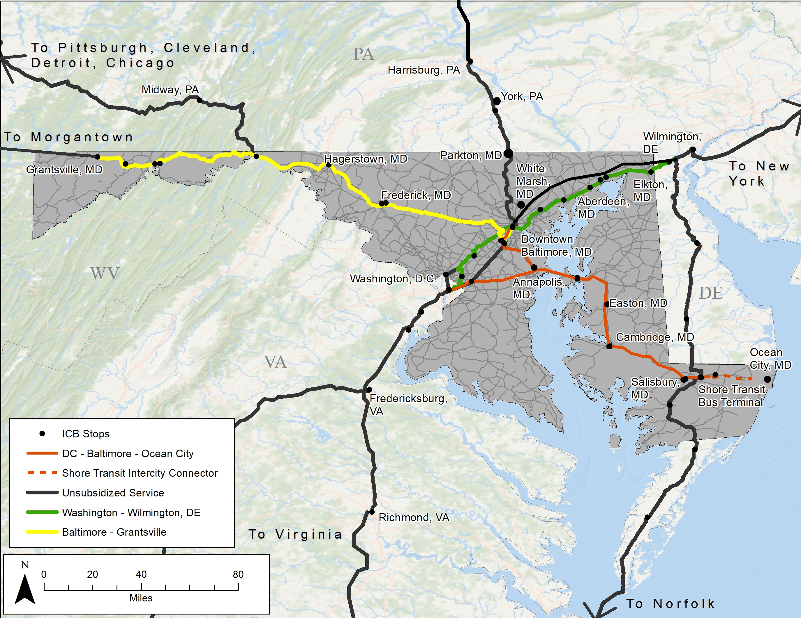

The basic service requirements for these corridors include one daily (Monday through Sunday) roundtrip connecting with the national intercity bus network.

However, this application will serve as an open solicitation and applicants can submit proposed projects in other corridors, as long as each proposed project is accompanied by documentation identifying and justifying the intercity transit need.

Feeder Service
Similarly, this program will consider funding services that are feeder services to intercity bus routes. The “coordination of rural connections between small transit operations and intercity bus carriers” may include the provision of service that acts as a feeder to intercity bus service, and which makes meaningful connections with scheduled intercity bus service to more distant points. These services must also operate a route that is a minimum distance of 35 miles one-way. “The feeder service is not required to have the same characteristics as the intercity service with which it connects”. For example, feeder services may be demand-responsive, while intercity service is by definition fixed route. Where feasible, intercity bus feeder service may also provide access to intercity connections with rail or air service. Also, rural transit providers operating feeder service with destinations across state lines are required to comply with the Federal Motor Carrier Safety Administration (FMCSA) regulations.

All applications for proposed projects must demonstrate local support as well as coordination and connectivity with other transit providers or other modes of travel.

Eligible applicants
To be eligible to submit an application to be considered for S. 5311(f) program funding, the applicant must be:
- A private, for-profit intercity carrier or provider;
- A private, non-profit operator proposing to provide intercity bus services;
- A local public transit operator providing or proposing to provide, feeder service to intercity carriers, or
- A public body proposing to provide intercity bus services.

Private for-profit applicants must submit a document showing evidence of organization. Private non-profit applicants are required to present proof of their non-profit status. All applicants must also have the approval of its executive board and, for current recipients of state/federal financial assistance for public transportation, a resolution by the governing board must be submitted with the application, a sample is provided in the assurances section of the application.

ALL CARRIERS that offer direct service or, as an interline partner offer service to points that cross-state lines, must hold the appropriate operating authority from the USDOT’s Federal Motor Carrier Safety Administration (FMCSA) and be in compliance and in good standing with the FMCSA as of July 1, 2022. All minivans and passenger vehicles designed to seat 11 or more persons (including the driver) that operate passenger transportation services in Maryland must display either a USDOT or a Maryland issued motor carrier identification number (MC number).

A carrier that has operated service under contractual agreement with MDOT MTA must have done so with no penalties imposed. The carrier shall remain ineligible for two years from the date of such penalty being imposed.

funding availability
Projects selected shall directly support the provision of intercity bus services in Maryland. For FY 2021 approximately $964,738 was available to support Section 5311(f) projects in Maryland. Funding allocations for FY 2023 have not been published by FTA, so the amounts available for FY 2023 and FY 2024 are not yet known but are likely to be comparable or higher. Projects may be recommended for complete, partial or no funding, based on application content and/or funding availability. MDOT MTA will notify applicants by May 2022 on the determination of their application.

If the total amount of Section 5311(f) funds requested by the selected projects is less than the available amount, excess funds may be returned to the 5311 program. In doing this, a Governor’s partial certification of no unmet rural intercity needs will be submitted to the FTA.

Technical Assistance

MDOT MTA is committed to providing technical assistance to all applicants. MDOT MTA responsibilities include:
- Providing technical assistance to applicants while completing the application
- Support coordination efforts
- Preparing a statewide comprehensive application for FTA
- Obtaining and maintaining project data; and
- On-going program evaluations and monitoring for federal and state
compliance.

For technical assistance in preparing this application, contact the MDOT MTA 5311(f) Intercity Bus Program Manager Bruce Hojnacki at 410-767-3758 or bhojnacki@mdot.maryland.gov.

PRELIMINARY APPLICATION REVIEW
The MDOT MTA will review applications individually to ensure that the applicant has met all the criteria of the application and has included all required forms, exhibits and attachments. Applications must contain evidence of local support such as letters or resolutions from local or regional organizations such as county boards/commissions, city councils, Metropolitan Planning Organizations (MPO) or Regional Planning Councils/Commissions (RPC). Applications found to be incomplete after the submission deadline has passed will not be considered for funding, so please make sure to contact the MDOT MTA and address ALL application requirements prior to the deadline.

APPLICATION evaluation AND RANKING

After the close of the application submittal period, the MDOT MTA staff will meet and evaluate the applications and rank them. Applications and supporting documents will be assessed based on 5311 Program Requirements, the 5311(f) Program definition, goals, objectives, and the Maryland Program Emphasis. Applications that do not meet the above criteria shall be returned. In the event of insufficient funding for all the projects determined to be eligible for funding, grants will be awarded based on the ranking received.

Although each applicant may apply for funding in more than one category, it is possible that awards may be made for one proposed activity and not another.

The list of approved projects will be released on May 13, 2022.

APPEAL PROCESS
Applicants may appeal the recommendation to not fund their application. The applicant must use the following process to be recognized as a valid appeal.

The applicant must submit a letter of appeal that clearly identifies the contact person, address, telephone number, project description and grounds for appeal.

Letters of appeal must be postmarked no later than 14 calendar days from the postmarked date of MDOT MTA notice about applicant’s funding status. Send letters to:
Travis Johnston, Director
Office of Local Transit Support
Maryland Department of Transportation/
Maryland Transit Administration
6 St. Paul Street, 8th Floor
Baltimore, MD 21202

The MDOT MTA Administrator’s office will review appeals and provide a written response within ten working days of the receipt of the appeal.

REQUIREMENTS FOR AWARDING OF GRANT CONTRACTS
Approved recipients must agree to all federal certifications and assurances in order to receive the grant award. Certifications and assurances include but are not limited to federal requirements for Disadvantaged Business Enterprise (DBE), Civil Rights, Transit Employee Projection, Lobbying, and Drug and Alcohol Testing. For more information, contact MDOT MTA ICB Program Manager Bruce Hojnacki at bhojnacki@mdot.maryland.gov or
410-767-3758.

Approved recipients must also agree to execute all Reporting Requirements as prescribed in the “Application Instructions” of this solicitation. This will include submission of a quarterly request for payment for reimbursement of expenses incurred during the previous quarter. The request for reimbursement should be the operations costs minus the fare revenue. The request for reimbursement will include monthly operations data and sample forms are provided. Depending on the type of project undertaken, there may be other reporting requirements.

Maryland DOT Number for Intrastate (i.e., within Maryland) Operation

Under Maryland law, private organizations that operate passenger transportation services in Maryland must display on commercial vehicles either a U.S. DOT number or a Maryland DOT motor carrier identification number obtained from the Maryland SHA’s Motor Carrier Division. For this requirement, Maryland has adopted the Federal Motor Carrier Safety Regulations (FMCSR) definition of commercial vehicles.

PRE-AWARD AUDIT
Approved recipients who have not previously received grants administered through the MDOT MTA, may be required to undergo a pre-award audit visit from MDOT MTA or MTA Office of External Audits. The purpose of the audit is to determine whether the recipient’s financial practices are able to clearly reflect how the grant funds will be used to successfully complete the approved Section 5311(f) projects.

OTHER REQUIREMENTS

  - Federal Motor Carrier Safety Administration (FMCSA) Registration
Intercity services providers crossing State lines are required to be in compliance with FMCSA regulations. Also, providers of intrastate service that interline with services to provide interstate trips (including public transit providers) must meet FMCSA regulations.

  - Rural transit providers operating feeder service with destinations across State lines are required to comply with FMCSA regulations. If applicable, applicant should provide proof of compliance.
  - Interstate feeder service may also trigger compliance with FMCSA regulations if inter-lining is involved (issuing a single ticket for the feeder service and the trip crosses state lines). If entering into an agreement, provide a copy with the 5311(f) application.
  - Meet certain insurance requirements as mandated by FMCSA, the resident State of operation (Maryland), or the State of travel (i.e. adjacent states).

  - Drug and Alcohol Requirements
All operators under this program are required to comply with federally-mandated Drug and Alcohol Policy and Procedures, and ensure that employees adhere to policy. For applicants that receive FTA financial assistance, and this supports a majority of their operations, please submit an approved Drug Free Workplace Policy and an approved Drug and Alcohol Testing Policy (refer to the FTA website: http://transit-safety.volpe.dot.gov/DrugAndAlcohol/Default.aspx for information.) For applicants that are private-for-profit carriers, please submit proof of approved Drug and Alcohol policy (refer to FMCSA website: http://www.fmcsa.dot.gov/safety-security/safety-initiatives/drugs/drugs-alcohol.htm for more information.)

  - Americans with Disabilities Act (ADA) Requirements
APPLICANTS PROPOSING TO OPERATE SERVICE MUST HAVE VEHICLES THAT ARE BOTH:
- ACCESSIBLE TO INDIVIDUALS WITH DISABLILITES AS DEFINED IN 49 CFR PART 38, AND
- AVAILABLE TO COMMENCE OPERATIONS ON JULY 1, 2022

All applicants must comply with 49 CFR Part 37 and Part 38. All operations must comply with Part 37, and all services operated under a Section 5311(f) agreement must be operated with vehicles that are accessible as defined in 49 CFR Part 38. Provision of accessible service on-demand with an advance reservation requirement is not acceptable, based on the federal requirements for this program.

Requests to purchase vehicles will not be approved unless the vehicle is wheelchair accessible as defined in 49 CFR Part 38. If the applicant is requesting a vehicle in this solicitation, the applicant must certify that it owns other accessible vehicles available for backup. As for facilities, any proposed facility improvements must address ADA accessibility before other improvements will be considered.

  - Public Information
To Support the intercity informational network by requiring applicants to provide their schedule to be published in one or more of the following methods:

  - By developing and maintaining GTFS data for all funded services and making this data available to MDOT MTA, Go Maryland, Google and other information platforms. MDOT MTA’s trip planner utilizes Google Transit, so inclusion of intercity bus route data should enable persons to plan trips that include intercity segments. Register in Google Transit through their website:
http://www.google.com/transit.
  - It is strongly encouraged that applicants enters into an interline ticketing agreement under the National Bus Ticketing System (NBTS). This can be done through either a direct membership in the National Bus Traffic Association (NBTA), or through sponsorship by a member of NBTA (such as Greyhound Lines).
  - Also, if interlining with Greyhound Lines, Inc., a Bus Terminal License is required to allow the applicant access to a Greyhound Lines, Inc. facilities (including the Baltimore Greyhound Bus Station); resulting in a more convenient transfer to connecting service.

  - National Transit Database (NTD) Reporting
In addition to data required with monthly or quarterly invoices to MDOT MTA, contractors are required to report 5311(f) intercity bus program activities annually to MDOT MTA. MDOT MTA completes Form RR-20 Spreadsheet Intercity on the National Transit Data Base (NTD) web site. The reporting period is from July to June, with the report due to the MDOT MTA by September. Items to include are:

  - Bus Vehicle Revenue Miles
  - Bus Unlinked Passenger Trips
  - 5311 grants for planning and capital expenses
  - 5311 grants for operating and provision of trips

  - Labor Protection Warranty
All Section 5311 operational projects, including intercity bus (5311(f)) projects, require agreement to the terms and conditions of the standard Section 5333(b) special warranty for the Section 5311 program. The assurance is included in the Certifications and Assurances section of this application.

  - Coordination
Applicants should reach out to local transit providers and planning agencies during the development of proposals to ensure that they are aware of potential intercity services, and to identify opportunities for shared stop locations, sharing of public information, etc. In the application forms, information provided by the applicant should include details about the applicant’s efforts to coordinate services with local agencies or public transportation providers.

  - Ownership and Control of Project Property (Capital Projects)
At all times while the PROJECT property is in the possession or control of the subgrantee, the subgrantee shall be the registered owner and the STATE shall be the legal owner or lien holder. The subgrantee shall not transfer ownership of the PROJECT property at any time while the grant agreement is in effect.

  - Other Federal and State Requirements
Recipients of funding applied for through this grant application must comply with Federal and State requirements pertaining to the 5311 program. For comprehensive guidance on Federal and State requirements for recipients of 5311(f) funding please refer to the MDOT MTA Locally Operated Transit Systems (LOTS) Program Manual (http://www.taminc.org/Portals/11/2017%20LOTS%20Manual.pdf)

FTA Circular C 9040.1G Formula Grants for Rural Areas: Program Guidance and Application Instructions, Chapter VIII, Intercity Bus.

